 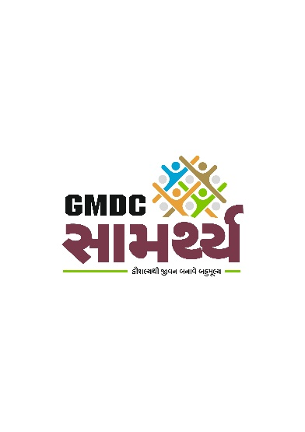 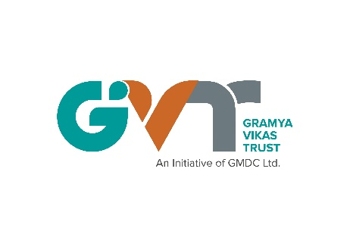



##### Case Stories

##### For

##### Samarthya Skill Training Centre Beneficiaries

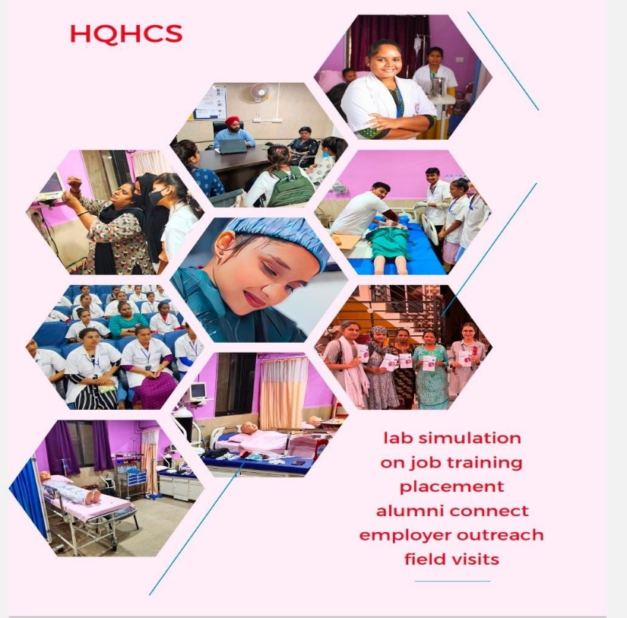

|  |  |
| --- | --- |
| **Vadodara-Center** | **Bhuj- Center** |
| Dr Reddy's Foundation, Kamaxi Kunj,  Old Sayaji Iron Campus, Shashtri Bridge,  Vadodara, Gujarat, 390002 | Dr Reddy's Foundation, Kataria HALL NO. 5, 1st Floor,above LIC office, Sanskar Nagar, Bhuj, Gujarat 370001 |

Supported by: **Gram Vikas Trust(GVT) &** **Gujarat Mineral Development Corporation(GMDC)**

**Introduction**

Dr. Reddy’s Foundation (DRF) is a not-for-profit organization set up in 1996 to enable socially and economically vulnerable groups to take control of their lives. We develop and test innovative solutions to address complex social problems and promote scaling up of impact by leveraging partnerships. We work with Children, Youth (including Persons with Disabilities) Women and Households across 20 States with multiple partners to create impact at scale. Our problems are aligned to 6 Sustainable Development Goals.

**PROBLEM**

India requires 65-Lakh Allied Health Care Professionals other than 20-Lakh Doctors and 40-Lakh Nurses.

1. Healthcare has become one of India's largest sectors both in terms of revenue and employment. During 2008-22, the market is expected to record a CAGR (compound annual growth rate) of 16.28 %
2. The total industry size is expected to touch US$ 372 billion by 2030
3. Increased population, improved life expectancy, private sector investment, National Health Policy 2017 recently launched Áyushman Bharat, and to fulfil the vision of health for all, will be the key drivers for this huge demand in India
4. One physician, on an average, requires support from 5.6 full-time employees such as medical assistance, nursing associates etc. to deliver quality healthcare service in different settings
5. Scarcity of quality delivery models

**OUR SOLUTION**

**Key 5 differentiators of HQHCS Program**

* High quality curriculum and assessment aligned to occupational standards, developed by industry experts
* In addition to technical training, “Core Employability Skills” is imparted to make youth fully prepared to join workforce
* Highly qualified Trainers (B.Sc & M.Sc Nurses)
* State of art Skill Lab
* Quality placement in reputed corporate hospitals
* Leveraging Govt. Infra

**Our Skilling Journey**

Dr. Reddy’s Foundation (DRF) has been working on skilling for the past 27 years and has impacted more than 4.75 lakh youth through its flagship skilling programs: Livelihood Advancement Business School (LABS), LABS-Persons with Disabilities (PwD), GROW, GROW-PwD, GROW-Plus and High Quality Healthcare Skilling (HQHCS).

**High Quality Healthcare Skilling (HQHCS) Program**

HQHCS program is designed to meet the huge demand of “Allied Healthcare Workers” by delivering high quality training at scale. (Refer to Box 1).

Following technical courses are currently offered which are aligned to National Occupational Standards.

***General Duty Assistant (Patient Care Assistant):***

20% of the core functions of a hospital system is managed by Doctors, 40% by Nurses. Additional workload mainly on Nurses is being reduced by introduction of *General Duty Assistant* (GDA). They provide patient care, comfort, safety, other health needs and help to maintain a suitable environment in Hospitals. Employment opportunities are in various Corporate and Private Hospitals, Nursing Homes and Diagnostic Centres.

Lack of trained and certified personnel has forced the industry to engage untrained & uncertified personnel for this job. EMTs are placed with various EMS Providers, including 108 Ambulance Network, PSUs, Public and Private Institutes, Multi-National companies. Hospital based Emergency Medical Services etc.

*Role of DRF*

1. Designing high-quality curriculum & assessment aligned to national occupational standards
2. Establishment of state of art Skill Lab
3. Accreditation by HSSC
4. Hiring of experienced and certified Trainers
5. Placement in corporate hospitals
6. Program monitoring and overall technical support to the program

**Point of Contact**

|  |  |  |  |  |
| --- | --- | --- | --- | --- |
| **Sl. No.** | **Employee Name** | **Designation** | **Contact Number** | **E-mail** |
| 1 | Gagandeep Singh Sachar | Sr. Regional Manager | 9016888816 | gagandeep.s@drreddysfoundation.org |

##### Process Followed to Ensure Start Batch

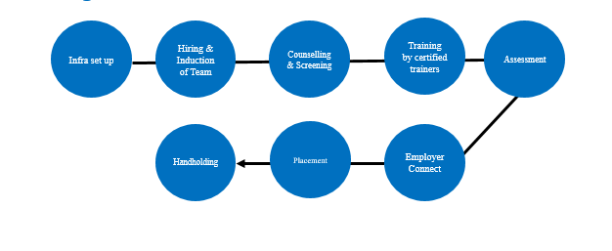

### Phase 1 - *Market scan*

A DRF-HQHCS team comprising of professionals from varied background did the market scan and analysis for a period of 7 days in Vadodara and Bhuj for the market scan for enumeration of potential livelihoods covering the revenue headquarters.

The findings of the market scan and analysis report threw light on the following aspects of Gujarat.

* Economy and People
* The Natural Resources
* The Industry Profile
* Labor market information
* Potential Livelihood Opportunities identified
* Business to youth (B2Y) network

### Phase 2 - *Curriculum development*

Based on the potential training courses the curriculum was developed with the help of experts from the Health care fields. GDA would ideally be running for 2.5 months to 3 months. Apart from the regular skill level training, the Soft skill and induction modules were designed to suit the unemployed youth.

### Phase 3 - *Capacity building training programs for faculty/Trainers*

The faculties were selected from the respective areas so as to inculcate the training through local flavor. The capacity building training program of course faculty, program staff was given online for a period of 4 days.

### Phase 4 – *Venue Finalization and Venue Set up with accreditation*

Preparations commenced on March 23 following the confirmation of venues in Bhuj and Vadodara. Concurrently, the process for accrediting centers was initiated

### *Phase 5 - Outreach and Community Awareness*

The Outreach and community awareness 4 district (Bharuch, Panchmahal, Chhotaudepur and Bhuj) and and around 450candidates came for the Road shows and Community Awareness of which 330 candidates shown their interest and 270 were enrolled for training, Mobilisation of youth from communities (from the identified villages) using direct & indirect outreach tools with the help of local bodies, institutions, NGOs etc. DRF will also conduct online campaigns using Facebook, google ads to reach out to youth.

### *Phase 6-Selection Process*

The Community Centres help in the mobilisation of required candidates for the livelihood skill development training programs. The program targeted the Areas/candidates who wanted immediate attention for their betterment. The Selection of Students - HQHCS is made on the following basis. The candidate should be:

* Youth who are needy (looking for job)
* Between 18-35years of age

One to one Counselling of aspirants with the support of counselling checklist is done to ensure the aspirants are ready for training and placement.

### *Phase 7-Training and Practical Sessions*

* GDA (Trainee) is a 490 hours program which includes modules on Soft Skills and English to be delivered by certified trainers in a state of art skill lab (theory 30%, practical & simulation 70%).
* Post assessment after the completing the course students to measure learning outcomes and Certification of candidates are done .

### *Phase 8-Emplyer connect – OJT and Placement*

* Employer Connect is a continuous process and 70% of youth will be placed in corporate hospitals or private clinics in INR 11,000-13,000 monthly salaried jobs.
* OJT for 15 days are planned and after OJT placement are done in hospital, clinics and diagnostic centers

### *Phase 9-Training and Practical Sessions*

* Post placement support is provided for a minimum of 6-months to mitigate attrition which is the highest during this period. Centre teams also organise monthly parents’ meet to engage parents in the program and counsel them to extend their support especially in case of female candidates so that they can continue in the job.

##### INFRA SETUP and CENTER ACCREDITION

Preparations commenced on March 23 following the confirmation of venues in Bhuj and Vadodara. Concurrently, the process for accrediting centers was initiated

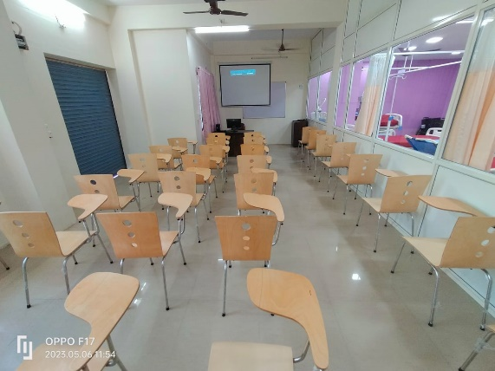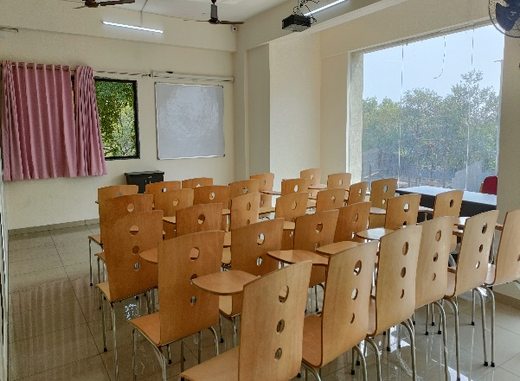

**CLASS ROOM**

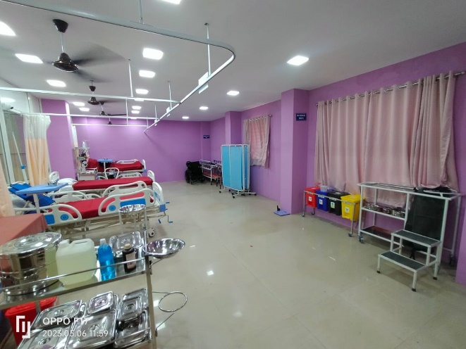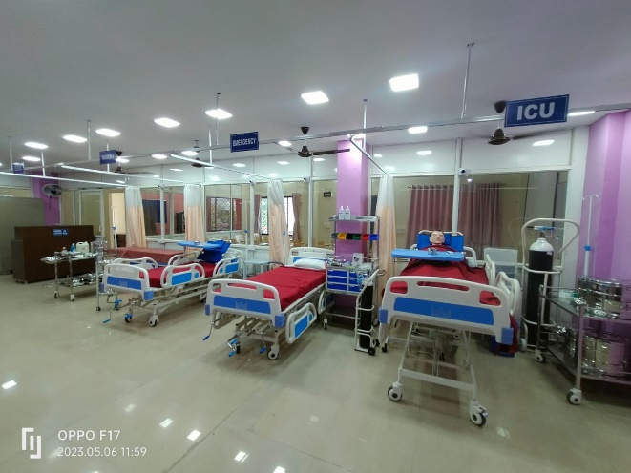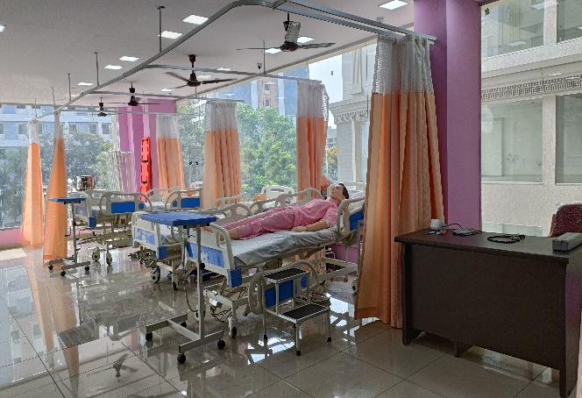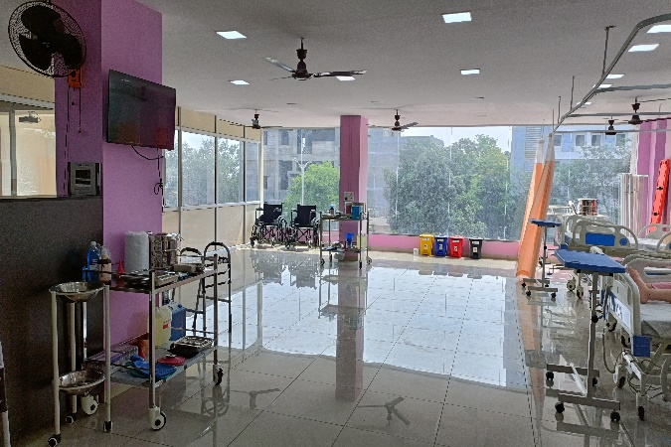

**WORLD CLASS LAB SETUP**

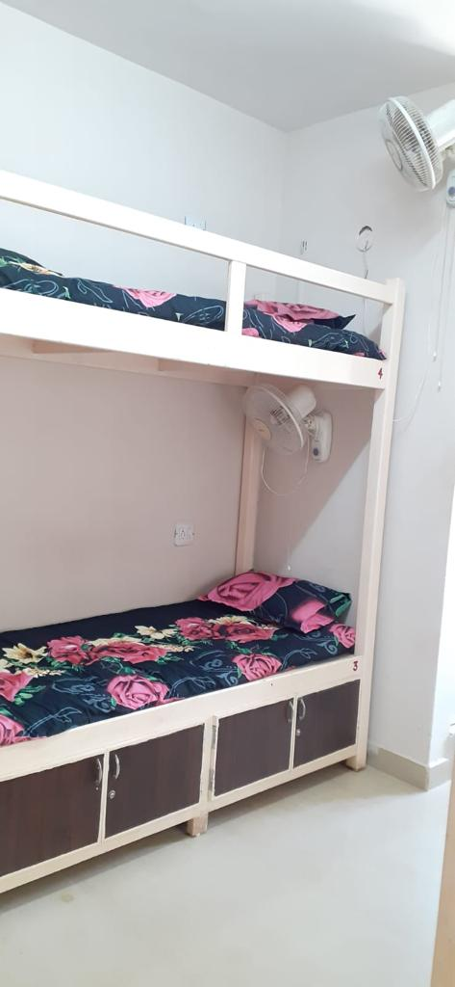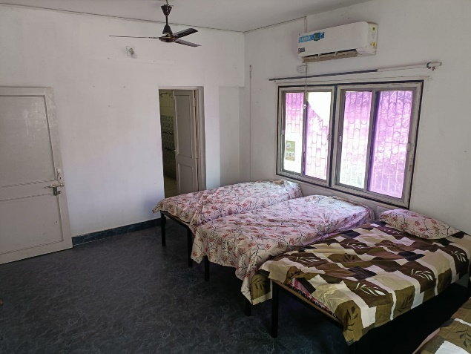

**HOSTEL FACILITIES**

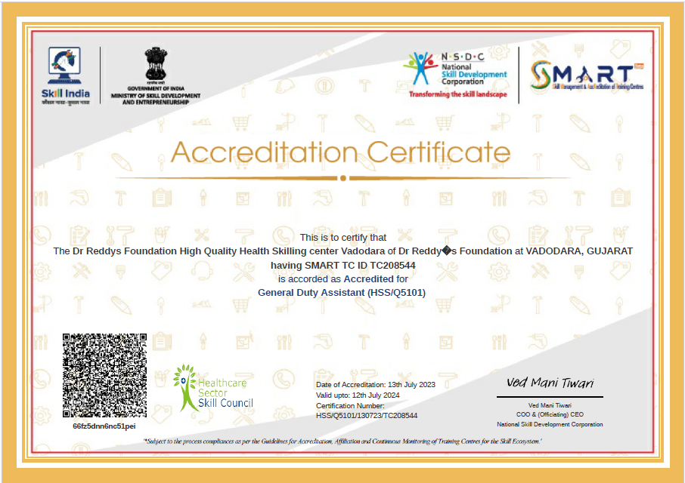 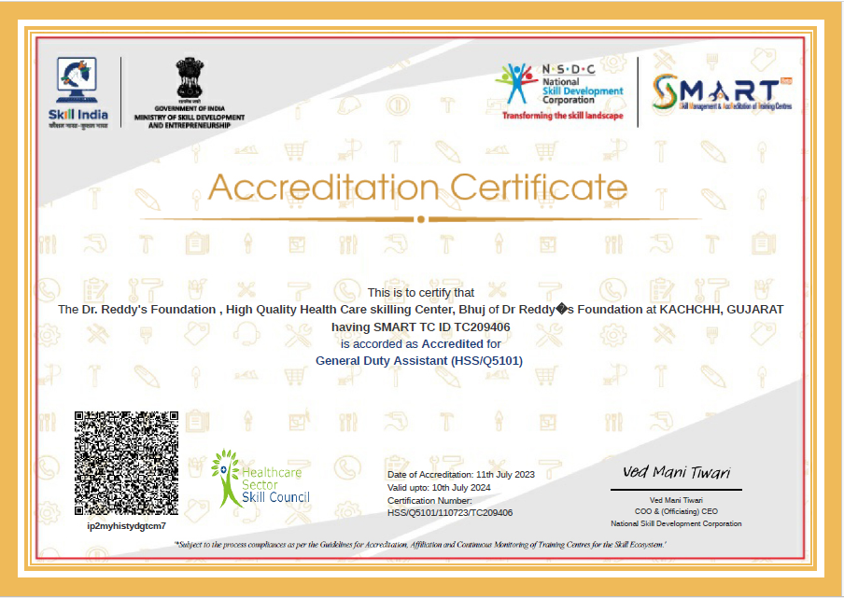

**Accreditation Certificates**

**CENTER IMPACT**

**To date, we have commenced 10 batches. The details are as under:Top of Form**

|  |  |  |  |
| --- | --- | --- | --- |
| **Center** | **Start Date of 1st Batch** | **Total Batches Started** | **Completed Batches** |
| **Bhuj** | **June 6th, 2023** | **4** | **3** |
| **Vadodara** | **July 21st, 2023** | **6** | **4** |

**Details regarding batch wise information are outlined below:**

|  |  |  |  |  |  |  |  |  |  |
| --- | --- | --- | --- | --- | --- | --- | --- | --- | --- |
| **Batch** | **Batch Start date** | **Batch End date** | **Inception** | **Completed** | **NSDC Certified – Pass** | **Placed aspirants** | **Placed %** | **Highest salary** | **Average Salary** |
|
| **DRFKUGD5** | **06-06-2023** | **03-09-2023** | **30** | **28** | **28** | **23** | **77%** | **19729** | **12227** |
| **DRFKUGD21** | **19-08-2023** | **16-11-2023** | **30** | **28** | **28** | **23** | **77%** | **17000** | **12430** |
| **DRFKUGD30** | **28-12-2023** | **11-03-2024** | **30** | **28** | **28** | **23** | **77%** | **23383** | **15333** |
| **DRFBHGD16** | **21-07-2023** | **07-10-2023** | **30** | **28** | **27** | **8** | **27%** | **23383** | **13692** |
| **DRFBHGD22** | **11-09-2023** | **02-12-2023** | **30** | **26** | **26** | **22** | **73%** | **19729** | **15615** |
| **DRFBHGD24** | **18-10-2023** | **20-12-2023** | **30** | **25** | **25** | **22** | **73%** | **19729** | **15615** |
| **DRFBHGD31** | **09-01-2024** | **22-03-2024** | **30** | **30** | **28** | **24** | **80%** | **16910** | **16887** |

**Placement Analysis as under:**

|  |  |
| --- | --- |
| **Geographical areas were aspirants placed** | **No of Placement** |
| **Bharuch** | **76** |
| Ahmedabad | 35 |
| Anand | 9 |
| Bharuch | 3 |
| Shivrajpur, Halol | 2 |
| Vadodara | 27 |
| **Kutch** | **69** |
| Ahmedabad | 13 |
| Bhuj | 55 |
| PANANDHRO | 1 |
| **Grand Total** | **145** |

ENABLING TRANSFORMATION

STORIES OF CHANGE

**HQHCS Bhuj - GMDC - Samarthya 1st Batch**

**Case Story 1:**

**Title: Breaking Barriers: The Inspiring Journey of Hina Dhanji Dungrakhiya**

**Introduction:**

Hina Dhanji Dungrakhiya, hailing from Nana Asambia in Mandvi, embarked on a remarkable journey to pursue her dream job in the healthcare sector after completing her 10th-grade education. Faced with the responsibilities of being a single parent child, with her mother and brother working as laborers, Hina's determination to support her family and fulfill her aspirations led her to the transformative GMDC Samarthya and GDA program, facilitated by Dr. Reddy's Foundation. Her journey exemplifies resilience, determination, and the transformative power of skill development initiatives in rural communities.

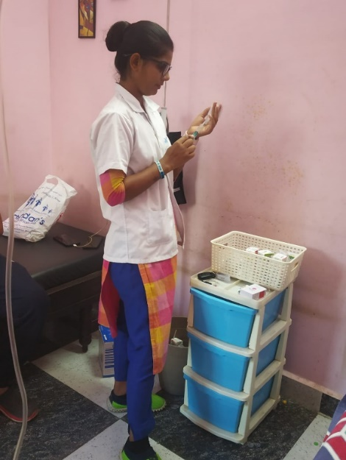**Background:**

Nana Asambia, situated in Mandvi, posed economic challenges for its residents, with limited opportunities for formal employment. Despite the hardships, Hina remained steadfast in her resolve to secure a stable job in the healthcare department, inspired by her desire to support her family and realize her dream of working in a hospital.

**Discovery of Opportunity:**

Hina's sister became the beacon of hope when she introduced her to the GMDC Samarthya and GDA program, facilitated by Dr. Reddy's Foundation. Recognizing the potential for growth and advancement, Hina seized the opportunity to enroll in the program, driven by her determination to break barriers and achieve her goals.

**Training and Skill Development:**

Over the course of three months, Hina immersed herself in intensive training under the GMDC Samarthya and GDA program. She honed her skills and acquired valuable knowledge in healthcare practices, emerging as a competent and confident professional ready to contribute to the sector.

**Employment at K.K Patel Hospital (Sanika Facilities Pvt. Ltd.):**

Upon completion of her training, Hina's perseverance bore fruit as she secured a job as a GDA Staff at K.K Patel Hospital in Bhuj, facilitated through Sanika Facilities Pvt Ltd. Despite the challenges she faced as a single parent child, Hina embraced her role with determination and enthusiasm, understanding the significance of her contribution to the healthcare ecosystem. she embraced the opportunity provided by Dr. Reddy's Foundation and turned it into a stepping stone towards her dream career and she gets 17000 (+Accommodation) salary per month and now her family income is 27000 per month.

**Transformation and Gratitude:**

Today, Hina stands as a testament to the resilience of the human spirit and the power of opportunity. Her journey from a modest background to gainful employment reflects the transformative impact of skill development initiatives. Hina expresses heartfelt gratitude to GMDC and Dr. Reddy's Foundation for illuminating her path and enabling her to realize her aspirations while supporting her family and also planning to Study in the future.

**HQHCS Bhuj - GMDC - Samarthya 1st Batch**

**Case Story 2:**

**Title: Overcoming Adversity: The Inspirational Journey of Kajal Shivji Grava**

**Introduction:**

Kajal Shivji Grava, hailing from Nana Asambia in Mandvi, faced numerous challenges in her quest to pursue a career in the healthcare sector. Despite completing her graduation, barriers such as education and economic factors initially hindered her path. However, driven by her determination to support her family and fulfill her dream of working in a hospital, Kajal's journey took a transformative turn when she discovered the GMDC Samarthya and GDA program facilitated by Dr. Reddy's Foundation. Her story is a testament to resilience, perseverance, and the transformative power of opportunity.

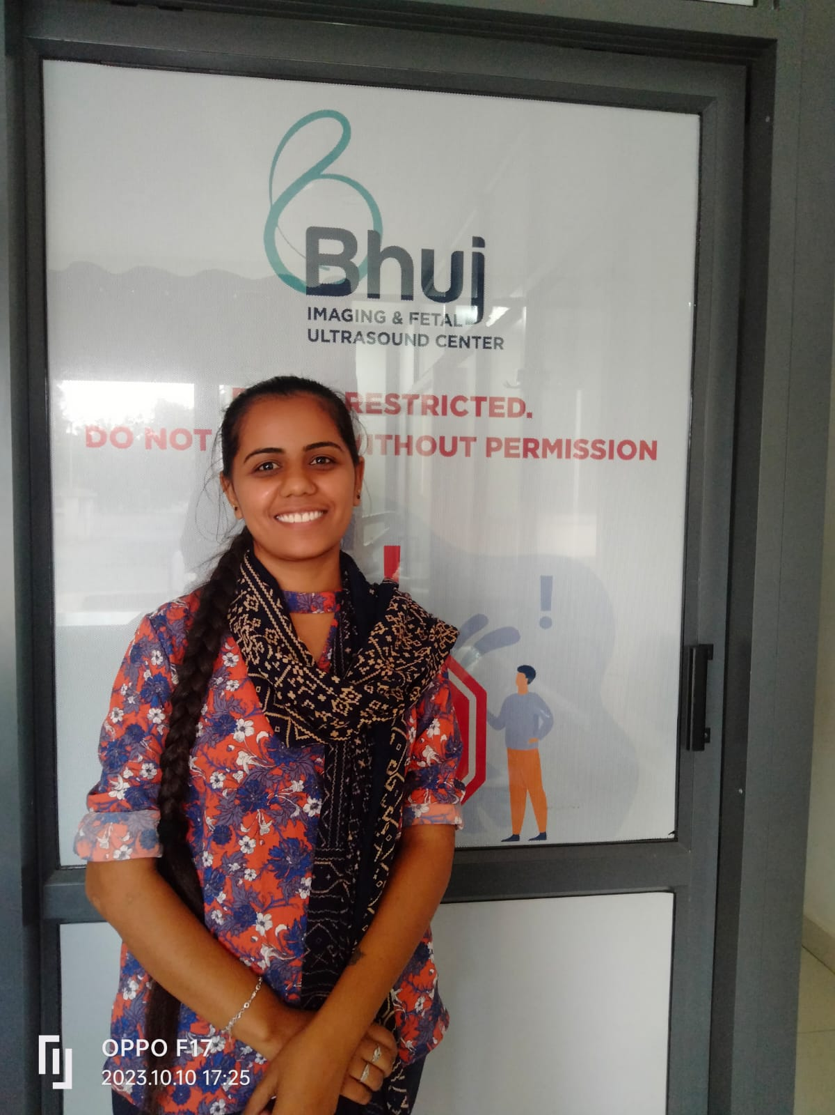**Background:**

In Nana Asambia, where Kajal grew up, economic constraints and limited educational opportunities posed significant challenges for aspiring individuals. Despite her graduation, Kajal's dream of working in the healthcare sector seemed unattainable due to various obstacles, including financial constraints and lack of specialized education.

**Discovery of Opportunity:**

Kajal's determination to pursue her dream led her to explore alternative avenues. Through social media and community meetings, she learned about the GMDC Samarthya and GDA program. Recognizing this as a potential opportunity, Kajal seized the chance to enroll in the program, seeing it as a pathway to realizing her aspirations.

**Training and Employment:**

Over the course of three months, Kajal underwent intensive training under the GMDC Samarthya and GDA program. Equipped with newfound skills and knowledge, she emerged as a competent professional ready to contribute to the healthcare sector. Her dedication and hard work paid off when she secured a job as a GDA Staff at Bhuj Imaging & Fetal Ultrasound Center. she embraced the opportunity provided by Dr. Reddy's Foundation and turned it into a stepping stone towards her dream career and she get 10000 salary per month and now her family income is 20000 per month.

**Transformation and Gratitude:**

Kajal's journey from facing broken dreams to realizing her aspirations brought immense happiness and fulfillment. She expresses profound gratitude to GMDC and Dr. Reddy's Foundation for providing her with the opportunity to fulfill her dreams and support her family. Now, with her dream job achieved, Kajal is also preparing to further her education by studying in the GNM program, demonstrating her commitment to continuous learning and growth.

**HQHCS Bhuj - GMDC - Samarthya 1st Batch**

**Case Story 3:**

**Title: Resilience Rewarded: The Journey of Bharat Mavaji Kunvat**

**Introduction:**

Bharat Mavaji Kunvat, a resident of Nana Asambia in Mandvi, faced significant challenges in pursuing a career in the healthcare sector after completing his 12th-grade education. Despite economic constraints and societal expectations, Bharat's unwavering determination to support his family and realize his dream of working in a hospital led him to discover the transformative GMDC Samarthya and GDA program, facilitated by Dr. Reddy's Foundation. His journey is a testament to resilience, perseverance, and the transformative power of opportunity.

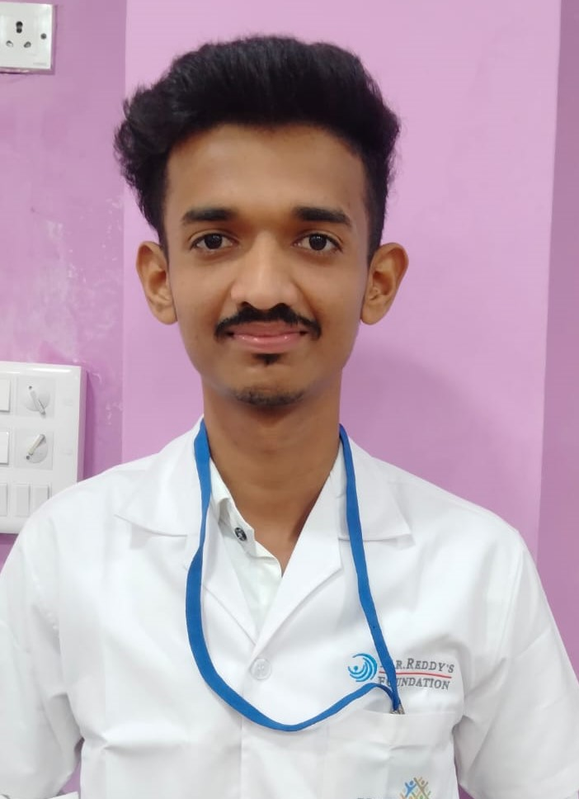**Background:**

In Nana Asambia, where Bharat grew up, economic hardships and limited educational opportunities often thwarted aspirations. Despite completing his 12th-grade education, Bharat's dream of working in the healthcare sector seemed unattainable due to financial constraints and lack of specialized education.

**Discovery of Opportunity:**

Bharat's quest for opportunity led him to community meetings where he learned about the GMDC Samarthya and GDA program. Recognizing this as a potential pathway to realizing his aspirations, Bharat seized the chance to enroll in the program, despite initial setbacks.

**Training and Employment:**

During the three-month training under the GMDC Samarthya and GDA program, Bharat displayed remarkable dedication and determination. Equipped with new skills and knowledge, he emerged as a competent professional ready to contribute to the healthcare sector. His hard work paid off when he secured a job as a Nursing Staff at Rainbow Children's Hospital in Bhuj. he embraced the opportunity provided by Dr. Reddy's Foundation and turned it into a stepping stone towards his dream career and he get 10000 salary per month and now his family income is 16500 per month.

**Transformation and Gratitude:**

Bharat's journey from shattered dreams to fulfilled aspirations brought immense happiness and fulfillment. He expresses profound gratitude to GMDC and Dr. Reddy's Foundation for providing him with the opportunity to realize his dreams and support his family. Now, with his dream job achieved, Bharat is empowered to make a meaningful difference in the lives of others while ensuring the well-being of his family

**HQHCS Bhuj - GMDC - Samarthya 2nd Batch**

**Case Story 4 :**

**Title: Empowering Dreams: The Journey of Bhanushali Falguni Girishbhai**

**Introduction:**

Bhanushali Falguni Girishbhai, a resident of Netra in Kutch, Gujarat, embarked on a transformative journey to fulfill her dream of working in the healthcare sector. Overcoming challenges and setbacks, Bhanushali's Falguni determination, coupled with the support of Dr. Reddy's Foundation and GMDC Samarthya, enabled her to realize her aspirations and support her family. Her story is a testament to resilience, determination, and the transformative power of opportunity.

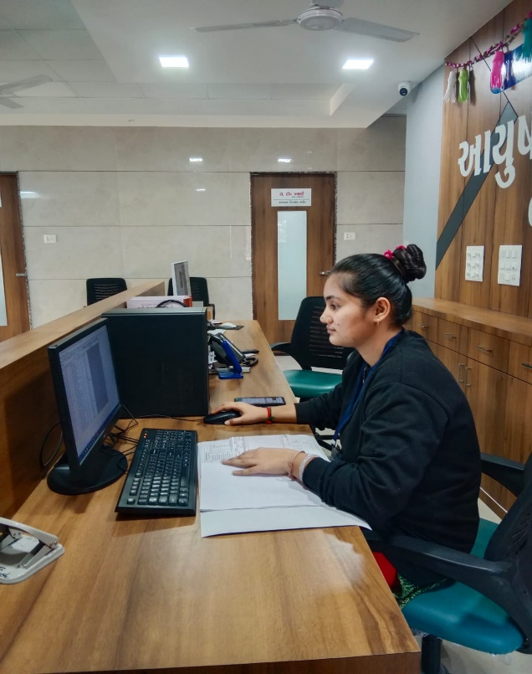**Background:**

Born and raised in Netra, Bhanushali Falguni aspired to work in healthcare, but due to educational factors, she initially pursued a career in the banking sector after completing her 12th-grade education. However, after facing financial difficulties in her father's household following her marriage, Bhanushali Falguni felt compelled to seek a new path to support her family and fulfill her dream.

**Discovery of Opportunity:**

Bhanushali Falguni journey took a positive turn when she learned about the free GDA program offered by Dr. Reddy's Foundation and GMDC Samarthya through a Community Meeting and her husband's encouragement. Recognizing this as an opportunity to pursue her dream career and support her family, Bhanushali Falguni eagerly enrolled in the program.

**Training and Employment at Aayush Super Specialist Hospital**:

Dedicated to her goal, Bhanushali Falguni completed the GDA program, equipping herself with the necessary skills for a career in the healthcare sector. Subsequently, she began working as a PRO (Public Relations Officer) with Aayush Super Specialist Hospital in Nakhtrana, Kutch, Gujarat, earning a monthly salary of 17,000 rupees. She embraced the opportunity provided by Dr. Reddy's Foundation and turned it into a stepping stone towards her dream career she get 17000 salaries per month and now her family income is 24500 per month.

**Transformation and Gratitude:**

Today, Bhanushali Falguni is not only fulfilling her dream but also supporting her family financially. Her journey from facing financial hardships to achieving professional success is a testament to the transformative impact of determination and opportunity. Bhanushali Falguni expresses heartfelt gratitude to Dr. Reddy's Foundation and GMDC Samarthya for their support and for enabling her to realize her aspirations and help her family.

**HQHCS Bhuj - GMDC - Samarthya 2nd Batch**

**Case Story 5 :**

**Title: From Adversity to Achievement: The Inspiring Journey of Jigna Baliya**

**Introduction:**

Jigna Baliya, a resident of Netra village, hailing from a financially disadvantaged background, embarked on a remarkable journey to fulfill her aspirations of becoming a nurse. Despite facing several challenges, she persisted with determination and eventually found success through the support of Dr. Reddy's Foundation and the GMDC Samarthya Project.

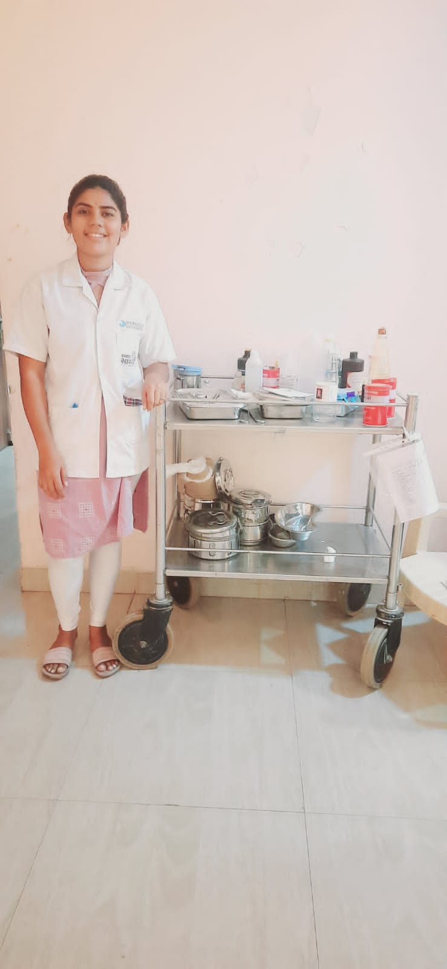**Background:**

Born into a poor family in Netra village, Jigna Baliya's dreams of pursuing higher education seemed distant due to financial constraints. However, her zeal to make a difference in people's lives through nursing never wavered. After completing her 12th grade, she set her sights on joining a nursing course to fulfill her ambitions.

**Challenges:**

The financial burden of her family made it challenging for Jigna to pursue a full-fledged nursing course. Despite her determination, she couldn't afford the expenses associated with a General Nursing and Midwifery (GNM) course, which she aspired for. This setback threatened to derail her dreams and left her uncertain about her future prospects.

**Turning Point:**

In the face of adversity, Jigna found a ray of hope through the GDA (General Duty Assistant) course offered by Dr. Reddy's Foundation. Recognizing the importance of gaining practical skills in the healthcare sector, she enrolled in the program, determined to utilize this opportunity to the fullest. Under the guidance of experienced mentors, she received comprehensive training as a Nursing Assistant, honing her skills and knowledge in patient care.

**Achievement:**

Upon completing the GDA course, Jigna's dedication and hard work bore fruit when she secured a job as a nurse staff at Accord Multi-Specialty Hospital. Her journey from aspiring nurse to a valued member of the healthcare team stands as a testament to her resilience and determination. Despite the initial setback of not being able to pursue her desired course, she embraced the opportunity provided by Dr. Reddy's Foundation and turned it into a stepping stone towards her dream career and she get 12000 salary per month and now her family income is 23000 per month.

**Gratitude:**

Jigna remains deeply grateful to Dr. Reddy's Foundation and the GMDC Samarthya Project for their unwavering support and belief in her potential. Their intervention not only enabled her to acquire the necessary skills but also paved the way for her to fulfill her aspirations against all odds. She acknowledges their role in shaping her journey and expresses heartfelt gratitude for their instrumental contribution to her success.

**HQHCS Bhuj - GMDC - Samarthya 2nd Batch**

**Case Story 6 :**

**Case Study Title: Niharika Zala: A Triumph of Determination and Family Support**

**Introduction:**

Niharika Zala, a resident of Gaduli-lakhpat, overcame socioeconomic challenges and limited educational opportunities for education and Career development in Lakhpat. This case study explores Niharika's journey, focusing on her decision to pursue GDA (General Duty Assistant) Training from Dr. Reddy's Foundation, her current role as an officer at K.K. Patel Super Specialists Hospital, and the pivotal support she received from her family.

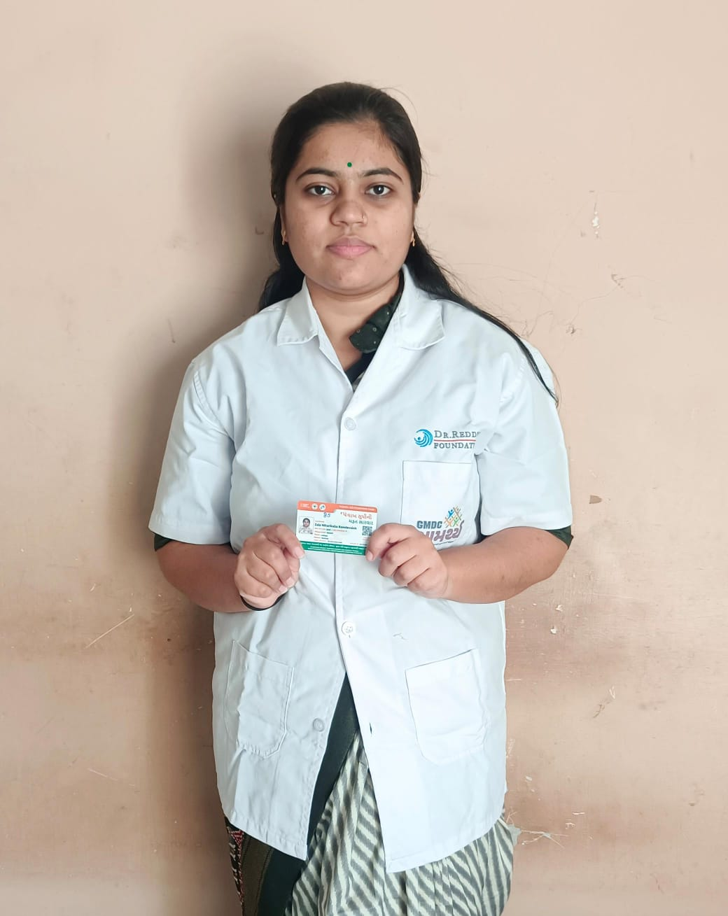

**GDA Training at Dr. Reddy's Foundation:**

Niharika's pursuit of a healthcare career led her to Dr. Reddy's Foundation, where she enrolled in the GDA Training program. The comprehensive training equipped her with essential skills, combining theoretical knowledge with hands-on experience. Niharika's dedication and aptitude earned her recognition, setting the stage for a successful transition into the healthcare industry.

**Professional Success at K.K. Patel Super Specialists Hospital:**

Today, Niharika serves as an officer at K.K. Patel Super Specialists Hospital, where she applies her GDA training to contribute meaningfully to patient care. Her role involves assisting medical professionals, maintaining patient records, and providing compassionate care. Niharika's dedication and skills have made her an invaluable member of the hospital team.

**Family Support:**

Niharika's journey wouldn't have been possible without the unwavering support of her parents. Recognizing her potential, they encouraged her pursuit of education and supported her decision to enroll in the GDA Training program. Their belief in Niharika's abilities played a crucial role in her success.

**Financial Impact and Gratitude:**

Niharika's professional success has not only fulfilled her career aspirations but also positively impacted her family's financial situation. Earning a monthly salary of 14500, she now contributes to her family's well-being and proves that education and skill development can break the cycle of economic constraints. Niharika remains deeply grateful to Dr. Reddy's Foundation and the GMDC Samarthya Project for their unwavering support and belief in her potential. She acknowledges their role in shaping her journey and expresses heartfelt gratitude for their instrumental contribution to her success.

**HQHCS Bhuj - GMDC - Samarthya 3rd Batch**

**Case Story 7 :**

**Title: From Education to Employment: The Journey of Bhagirath Khajurbhai Purohit**

**Introduction:**

Bhagirath Khajurbhai Purohit, hailing from Gaduli Lakhpat, faced the common challenge of many youths in rural areas - the transition from education to employment. Having completed his 10th-grade education, he found himself at a crossroads, unsure of his next steps. However, his determination to secure a stable job led him on a transformative journey facilitated by the GMDC Samarthya GDA program, orchestrated by Dr. Reddy's Foundation.

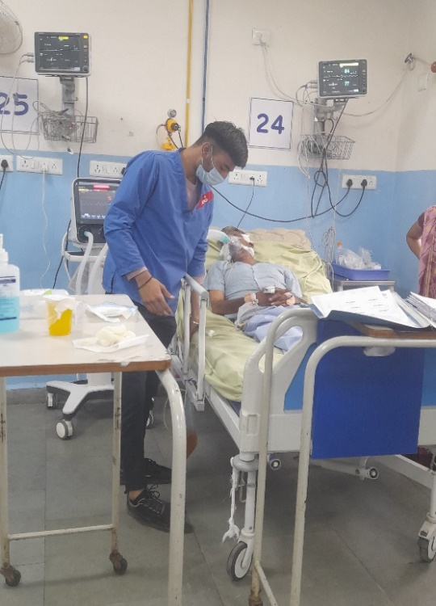**Background:**

Gaduli Lakhpat, a rural community, lacked ample opportunities for formal employment, especially for individuals with limited education. Bhagirath's situation mirrored that of many youngsters in the area, where aspirations were often stifled by the absence of proper guidance and opportunities. He has 6 Members in his family and his father works in a Private Company.

**Discovery of Opportunity:**

Bhagirath's breakthrough came during a community meeting where he learned about the GMDC Samarthya GDA program, a skill development initiative aimed at empowering youth in rural areas. Spearheaded by Dr. Reddy's Foundation, the program offered comprehensive training and placement assistance in various sectors, including healthcare.

**Training and Skill Development:**

Recognizing the growth potential, Bhagirath seized the opportunity and enrolled in the GMDC Samarthya GDA program. Over the course of three months, he underwent rigorous training, honing his skills in healthcare practices and professional conduct. The program not only equipped him with technical expertise but also instilled confidence and a sense of purpose.

**Employment at Adani G.K Hospital (SODEXO):**

Upon completion of the training program, Bhagirath's dedication and newfound skills paved the way for employment opportunities, he secured a position as a GDA at Adani G.K Hospital in Bhuj. Despite being hired through a third-party arrangement with Sodexo, Bhagirath embraced his role wholeheartedly, understanding the significance of his contribution to the healthcare ecosystem.

**Transformation and Gratitude:**

Today, Bhagirath stands as a testament to the transformative power of skill development initiatives in rural communities. His journey from a modest educational background to gainful employment reflects the untapped potential within such regions. Bhagirath expresses profound gratitude to GMDC and Dr. Reddy's Foundation for illuminating his path and enabling him to realize his aspirations. he embraced the opportunity provided by Dr. Reddy's Foundation and turned it into a stepping stone toward his dream career and he got 11565 salary per month and now his family income is 17565 per month.

**HQHCS Bhuj - GMDC - Samarthya 3rd Batch**

**Case Story 8:**

**Title: Fulfilling Dreams: The Journey of Khusbuben Harjibhai Kunvat**

**Introduction:**

Khusbuben Harjibhai Kunvat, a determined individual from Naredi in Abdasa, embarked on a journey to pursue her dream of working in the healthcare sector after completing her 12th-grade education. With a desire to support her family and fulfill her aspirations, she found her path illuminated by the GMDC Samarthya and GDA program, facilitated by Dr. Reddy's Foundation. Through her perseverance and the support of her community, Khusbuben's dream of working in a hospital became a reality, bringing her profound happiness and gratitude towards GMDC and Dr. Reddy's Foundation.

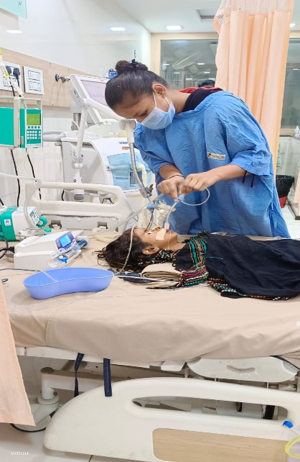**Background:**

Naredi, situated in Abdasa, faced economic challenges, and formal employment opportunities were scarce, especially in sectors like healthcare. Khusbuben, driven by her passion for helping others and her family's needs, sought avenues to realize her ambitions.

**Discovery of Opportunity:**

Khusbuben's journey towards her dream job began when a community leader and her brother introduced her to the GMDC Samarthya and GDA program. This initiative, supported by Dr. Reddy's Foundation, aimed to empower rural youth by providing skill development training and job placement assistance in sectors like healthcare.

**Training and Skill Development:**

Recognizing the opportunity, Khusbuben eagerly enrolled in the GMDC Samarthya and GDA program. Over the course of three months, she underwent rigorous training, acquiring essential skills and knowledge necessary for a career in healthcare. The program not only equipped her with technical expertise but also nurtured her confidence and determination.

**Employment at New Life Children's Care Hospital:**

Upon completing her training, Khusbuben's dedication and newfound skills led to employment opportunities. She secured a position as an assistant nurse at New Life Children's Care Hospital in Bhuj. This achievement marked the realization of her dream and brought immense joy and fulfillment to Khusbuben.

**Transformation and Gratitude:**

Today, Khusbuben stands as a symbol of determination and perseverance in her community. Her journey from a rural background to meaningful employment exemplifies the transformative power of education and skill development initiatives. Khusbuben expresses heartfelt gratitude to GMDC and Dr. Reddy's Foundation for their support and guidance, which enabled her to fulfill her aspirations and contribute to her family's well-being. he embraced the opportunity provided by Dr. Reddy's Foundation and turned it into a stepping stone toward his dream career and he got 8000(+Accomodation) salaries per month and now his family income is 13000 per month. she is happy for get a good job.

**HQHCS Bhuj - GMDC - Samarthya 3rd Batch**

**Case Story 9:**

**Title: Empowering Dreams: The Journey of Rajesh Naran Siju**

**Introduction:**

Rajesh Naran Siju, a native of Naredi, Lakhpat, found himself at a crossroads after completing his 10th-grade education, yearning for a stable job in the healthcare sector. His journey towards fulfillment and success was catalyzed by the GMDC Samarthya GDA program, facilitated by Dr. Reddy's Foundation, showcasing the transformative impact of skill development initiatives in rural communities.

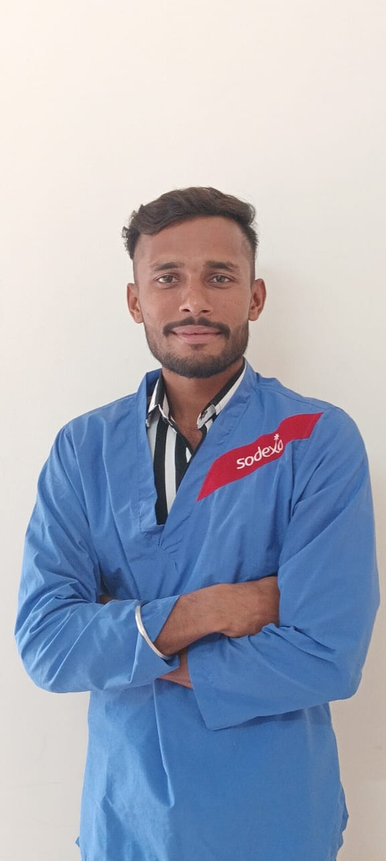**Background:**

Naredi, situated in Abdasa, presented limited opportunities for formal employment, particularly in specialized sectors like healthcare. Rajesh, like many others in his community, faced the daunting task of navigating the transition from education to meaningful employment.

**Discovery of Opportunity:**

Rajesh's journey took a fortuitous turn when he got information about the program through social media Templates for the GMDC Samarthya GDA program. This initiative, spearheaded by Dr. Reddy's Foundation, aimed to empower rural youth by providing comprehensive skill development training and placement assistance in various sectors, including healthcare.

**Training and Skill Development:**

Recognizing the potential for growth and advancement, Rajesh seized the opportunity and enrolled in the GMDC Samarthya GDA program. Over the course of three months, he underwent intensive training, acquiring essential skills and knowledge pertinent to the healthcare domain. The program not only equipped him with technical expertise but also instilled a sense of confidence and purpose.

**Employment at Adani G.K Hospital (Sodexo):**

Upon completion of the training program, Rajesh's dedication and newfound skills opened doors to employment opportunities. Through the program's collaboration with Sodexo, he secured a position at Adani G.K Hospital in Bhuj. Despite being employed through a third-party arrangement, Rajesh embraced his role with enthusiasm, understanding the significance of his contribution to the healthcare sector.

**Transformation and Gratitude:**

Today, Rajesh stands as a beacon of hope and inspiration in his community. His journey from a modest educational background to gainful employment exemplifies the potential for growth and success inherent within rural areas. Rajesh expresses profound gratitude to GMDC and Dr. Reddy's Foundation for illuminating his path and enabling him to realize his aspirations. he embraced the opportunity provided by Dr. Reddy's Foundation and turned it into a stepping stone toward his dream career and he got 11565 salary per month and now his family income is 17565 per month. He Gives 1st salary to his mother she is really happy that now her son is getting a good job.

**HQHCS Vadodara - GMDC - Samarthya 1st Batch**

**Case Story:1**

**Title**: **Empowering Change: The Story of Savita from Ambadungar Village**

**Introduction:**

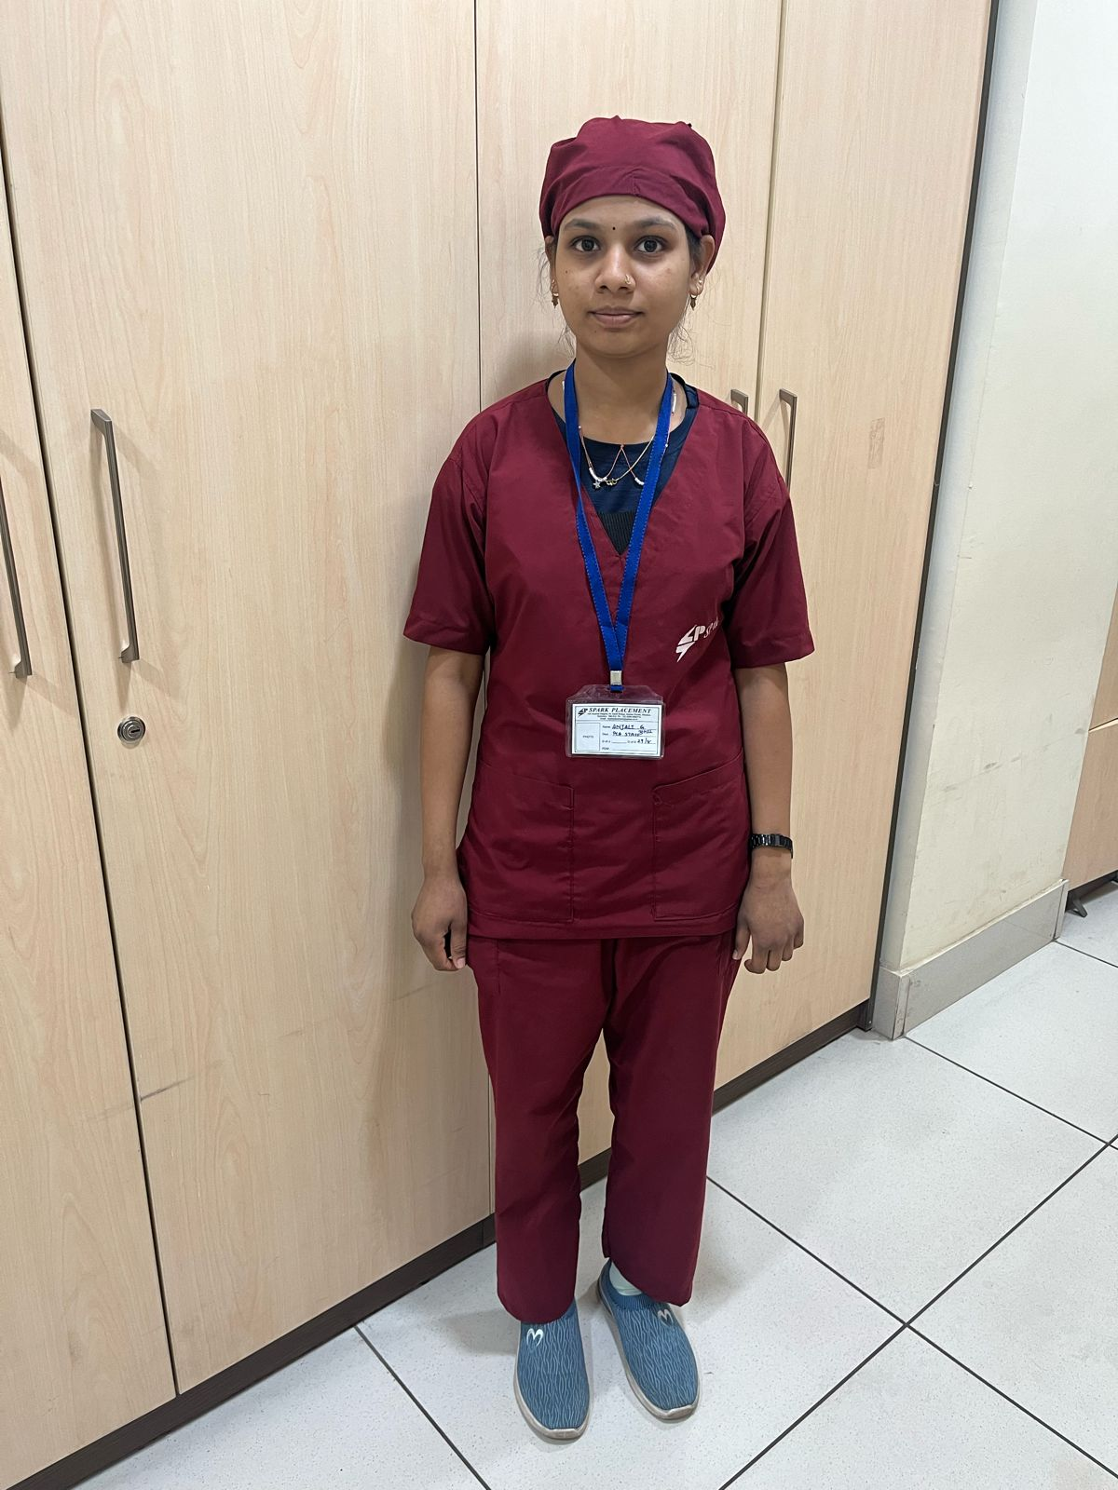Savita's journey from Ambadungar village in Chhotaudepur district, Gujarat, is a tale of resilience and determination. Despite her limited education and familial responsibilities, Savita seized the opportunity provided by the General Duty Assistant Course to support her family and achieve financial independence. Her journey exemplifies the transformative power of education and opportunity in empowering individuals to overcome challenges and realize their potential.

**Background**:

Born into a family of seven members, Savita understood the importance of contributing to her family's income from a young age. With her father working as a driver in Maharashtra and her mother caring for the family at home, Savita took on the responsibility of assisting her family financially. Despite her limited education, she worked as a daily wage laborer in nearby farms to make ends meet.

**Discovery of Opportunity**:

Savita's journey took a significant turn when she learned about the General Duty Assistant Course through a village meeting. Recognizing this as an opportunity to acquire valuable skills and improve her prospects, Savita eagerly pursued information about the course and prepared herself for the selection process.

**Training and Employment**:

Driven by her determination to succeed, Savita dedicated herself to the course and excelled in the selection interviews. Her efforts paid off when she secured a position at Adicura Hospital in Vadodara, with a monthly salary of 16,633 Rs. This employment not only provided Savita with financial independence but also allowed her to support her family's needs.

**Gratitude and Recognition**:

Savita expresses deep gratitude to GMDC and Dr. Reddy's Foundation for providing her with the opportunity to become self-sufficient and support her family. Her dedication and hard work have been recognized by her employer, who appreciates her behaviour and commitment to her work. Savita's success is a source of pride for her family and a testament to the transformative impact of education and opportunity.

**Conclusion**:

Savita's journey from a daily wage laborer to a skilled healthcare professional is a testament to the resilience of the human spirit. Her story underscores the importance of seizing opportunities and persevering in the face of adversity. Through her determination and dedication, Savita has not only transformed her own life but has also become a source of inspiration for others in her community.

**HQHCS Vadodara - GMDC - Samarthya 1st Batch**

**Case Story:2**

**Title: From Aspiration to Achievement: Dixesh Rathva's Journey**

**Introduction**:

Dixesh Rathva, hailing from Khasra village of Chhotaudepur district of Gujarat, embarked on a transformative journey to support his family and fulfil his aspirations. Despite completing his education till the 10th grade and pursuing a sewing course at a nearby ITI, Dixesh realized that his earnings were insufficient to meet his family's needs. Determined to become a contributing member of his family, Dixesh seized the opportunity presented by a community mobilizer and enrolled in a training program. His dedication, hard work, and perseverance paved the way for his success, as he emerged as a top performer in his batch and secured employment as a patient care assistant with Orion Enterprises Pvt. Ltd. In Zydus Hospital, Vadodara.

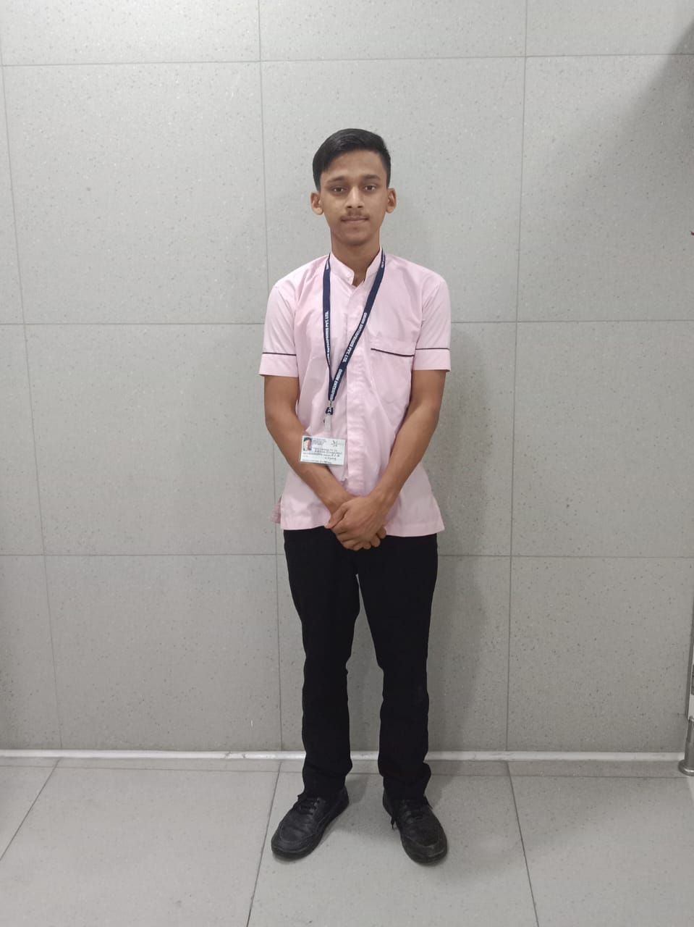**Background:**

Dixesh Rathva's journey began in Khasra village, where he pursued his education up to the 10th grade before enrolling in a sewing class at a local ITI. Despite his efforts, Dixesh realized that his income from sewing clothes at home was insufficient to support his family.

**Discovery of Opportunity:**

During the mobilization process, Dixesh encountered a community mobilizer who introduced him to a training program. Recognizing this as an opportunity to enhance his skills and improve his prospects, Dixesh eagerly enrolled in the program.

**Training and Employment**:

Dixesh dedicated himself wholeheartedly to the training program, focusing on honing his technical skills and improving his communication abilities. His hard work and determination paid off, as he emerged as one of the top performers in his batch. Recognizing his potential, Orion Enterprises Pvt. Ltd. offered Dixesh a position as a Trainee, which he gladly accepted. He now works as a patient care assistant, earning a monthly salary of Rs 23,383

**Impact and Inspiration**:

Dixesh's success story serves as an inspiration to the adolescents in his village, demonstrating the transformative power of determination and hard work. Additionally, his employer commends Dixesh for his dedication and behavior, further validating his success and contribution to the workplace.

**Conclusion:**

Dixesh Rathva's journey from a struggling seamster to a successful patient care assistant exemplifies the transformative impact of seizing opportunities and dedication to personal growth. His story serves as a beacon of hope and inspiration, illustrating the potential for individuals to overcome obstacles and achieve their aspirations through perseverance and determination

**HQHCS Vadodara - GMDC - Samarthya 1st Batch**

**Case Story:3**

**Title: Rising Above Adversity: The Inspirational Journey of Viran Rathva**

**Introduction**:

Viran Rathva's journey is a testament to resilience, determination, and the transformative power of opportunity. Despite facing challenges and doubts about his abilities, Viran's journey led him from uncertainty to success, as he emerged as a sincere and dedicated student in his training program. His perseverance and hard work ultimately led to his employment as a Patient Care Assistant, validating his potential and abilities.

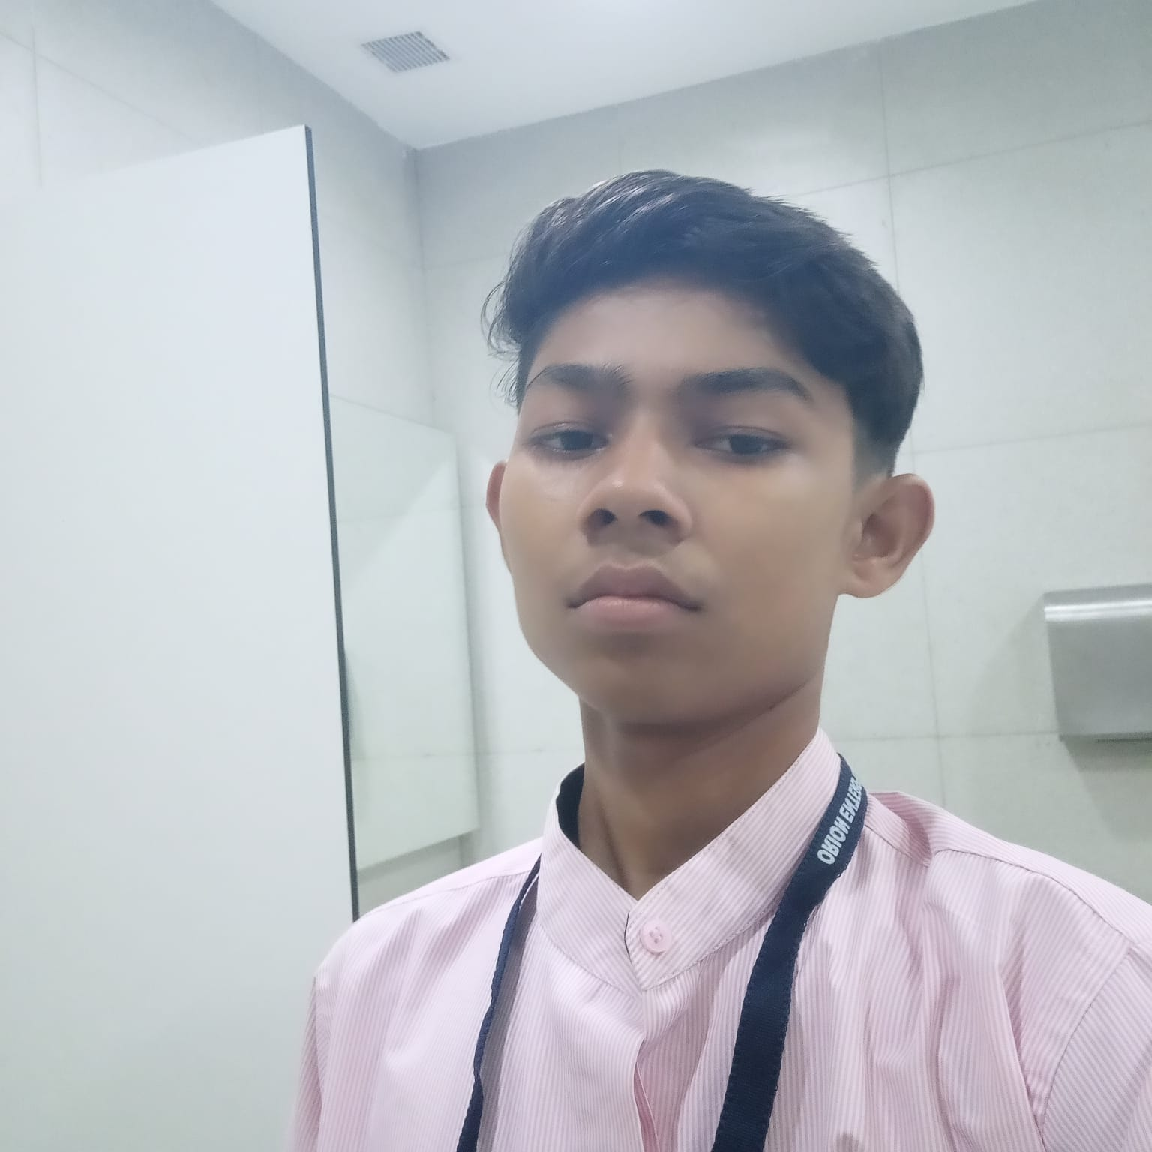**Background:**

Having completed his 10th grade in 2020, Viran harbored doubts about his academic abilities, particularly after realizing that his passing grade may have been influenced by external factors such as the COVID-19 pandemic. Despite this uncertainty, Viran stopped studying and found himself at a crossroads regarding his future.

**Discovery of Opportunity:**

Viran's journey took a positive turn when he learned about a training program through a close friend who had also enrolled. Recognizing this as an opportunity to improve his prospects and support his family, Viran decided to join the program despite his initial doubts.

**Challenges and Transformation:**

Viran's journey was fraught with challenges, and at one point, he contemplated leaving the program. However, after receiving counselling and understanding the importance of earning to support his family, Viran recommitted himself to the program. His dedication and hard work led to a significant transformation, as he emerged as one of the sincerest students in his batch.

**Employment and Validation**:

Despite facing initial rejections due to his height during interviews, Viran remained resilient and continued to pursue opportunities. Eventually, his perseverance paid off when he secured a position as a Patient Care Assistant. This employment not only provided financial relief but also served as validation of Viran's abilities and potential.

**Conclusion:**

Viran Rathva's journey exemplifies the power of perseverance, determination, and seizing opportunities in the face of adversity. His transformation from uncertainty to success is a testament to the transformative impact of hard work and dedication. Viran's story serves as an inspiration to others, demonstrating that with resilience and determination, one can overcome challenges and achieve their aspirations.

**HQHCS Vadodara - GMDC - Samarthya 2nd Batch**

**Case Story:4**

**Title: Empowering Change: Asha's Journey to Self-Sufficiency**

**Introduction:**

Asha's journey from Ghogadva Faliya in Shivrajpur village, Panchmahal district of Gujarat, is a testament to resilience and determination in the face of adversity. Born into a single-parent household with two brothers, Asha witnessed her family's struggles to make ends meet without the presence of her father. Despite facing challenges, Asha seized the opportunity provided by the training program to secure a job in the hospital sector, fulfilling her dream of earning and supporting her family.

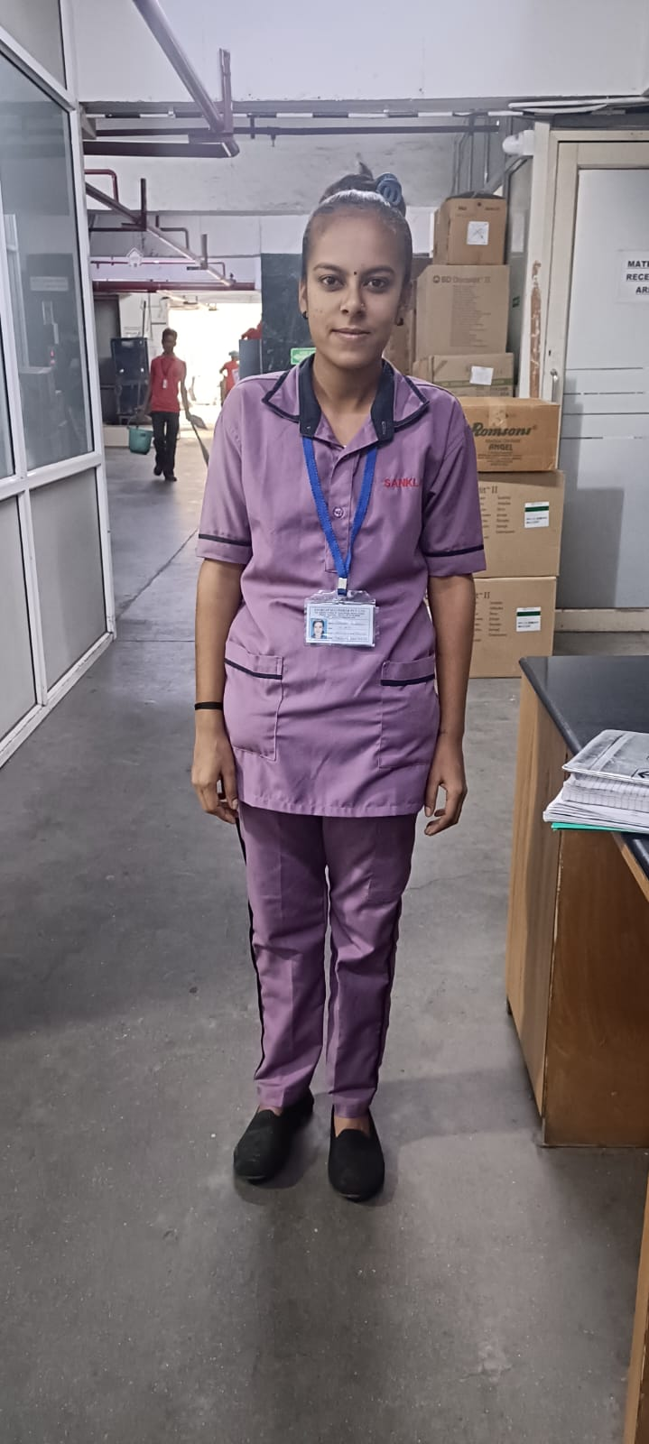**Background:**

Growing up in Ghogadva Faliya, Asha experienced first-hand the hardships faced by her family in the absence of her father. With her elder brother working at a petrol pump and her younger brother employed as a labourer in a nearby shop, Asha understood the importance of contributing to her family's income from a young age.

**Discovery of Opportunity:**

Motivated by her desire to ease her family's financial burden and fulfil her own aspirations, Asha enrolled in the training program. She saw it as a chance to acquire skills that would enable her to secure a stable job in the hospital sector, where she had always wanted to work.

**Training and Employment:**

Throughout the training program, Asha demonstrated dedication and determination, preparing herself for the opportunities that lay ahead. Upon completion of the program, she successfully interviewed with Spark Placement Pvt. Ltd. and was placed in Sunshine Global Hospital, Manjalpur, as a patient care assistant. With a monthly salary of 13,494 Rs, Asha not only achieved her goal of earning but also became a vital support for her family.

**Recognition and Future Endeavors:**

Asha's journey serves as an inspiration to her peers and community, showcasing the power of perseverance and seizing opportunities for self-improvement. As she continues her journey towards self-sufficiency and personal growth, we extend our best wishes to Asha for her future endeavors.

**Conclusion**:

Asha's journey from a struggling household to a secure job in the hospital sector is a testament to her resilience and determination. Through her hard work and dedication, she has not only transformed her own life but has also become a beacon of hope for her family and community. Asha's story reminds us of the importance of perseverance and seizing opportunities in pursuit of a better future.

**HQHCS Vadodara - GMDC - Samarthya 2nd Batch**

**Case Story:5**

**Title: Sonalben Vasava: A Journey of Determination and Dedication**

**Introduction:**

Sonalben Vasava's hails from Amalzar village in Jhagadia Taluka, Bharuch district, her journey is a testament to her unwavering determination and commitment to supporting her family despite financial constraints. Born into a humble family with limited resources, Sonalben always harbored a desire to work in a hospital and contribute to her family's well-being. Despite facing challenges due to her lack of education, Sonalben seized the opportunity provided by the General Duty Assistant course to fulfill her aspirations and become a vital support for her family.

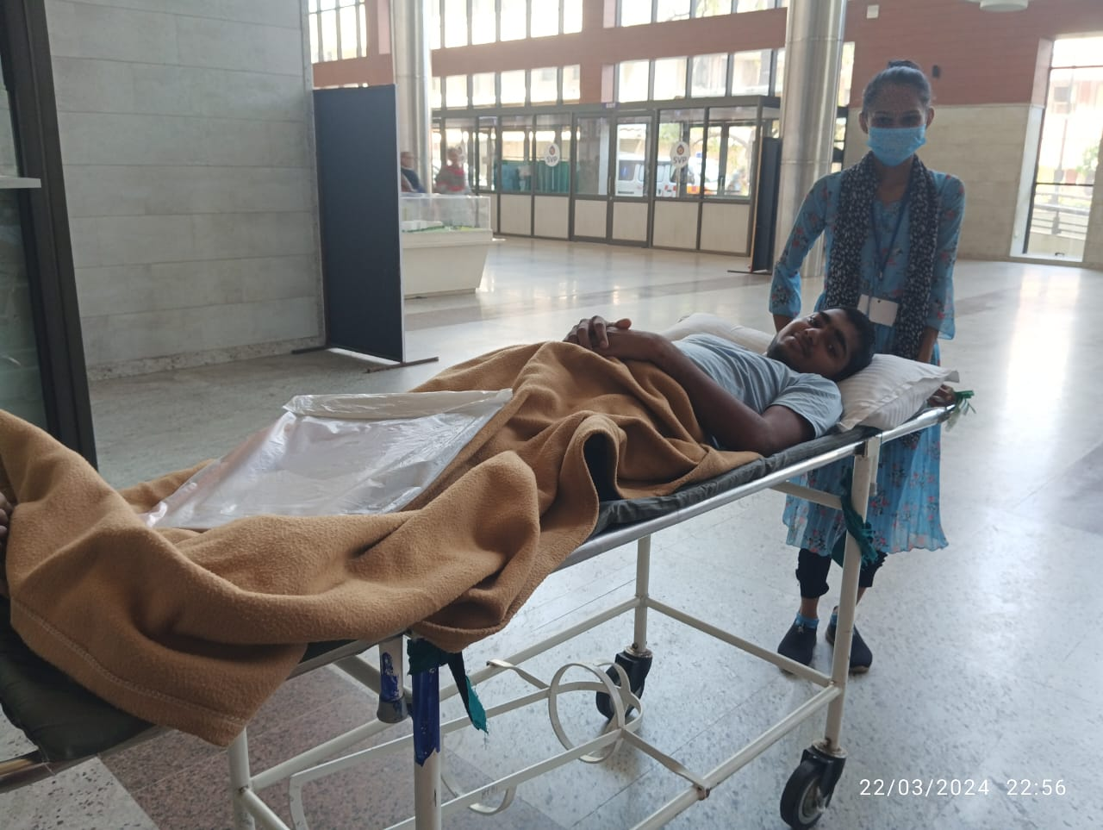**Background**:

Growing up in Amalzar village, Sonalben witnessed the struggles of her family, with her mother managing the household and her brothers working in labor and farming roles. Despite her desire to contribute financially, Sonalben's lack of education limited her options for employment.

**Discovery of Opportunity**:

Sonalben's journey took a positive turn when she learned about the General Duty Assistant course through our mobilizer. Recognizing this as an opportunity to acquire skills and secure a job in the hospital sector, Sonalben eagerly enrolled in the course alongside a few friends.

**Training and Employment**:

Throughout the course, Sonalben distinguished herself as a punctual and dedicated student, always wearing a smile and offering assistance to her fellow classmates. Her hard work and commitment paid off when she secured a position as a Patient Care Assistant with Vishv Enterprise at Sardar Vallabhbhai Patel Hospital in Ahmedabad. With a monthly salary of 11,500 rupees for an 8-hour shift, Sonalben not only achieved her dream of working in a hospital but also became a valuable contributor to her family's income.

**Gratitude and Well-Wishes:**

Sonalben expresses heartfelt gratitude to GMDC and Dr. Reddy's Foundation for providing her with the opportunity to realize her aspirations and support her family. As she embarks on her career journey, we extend our best wishes to Sonalben and hope to see her fulfill all her dreams and aspirations.

**Conclusion:**

Sonalben Vasava's journey exemplifies the power of determination and seizing opportunities to overcome obstacles and achieve one's goals. Her unwavering commitment to her family's well-being and her own aspirations serves as an inspiration to others. As Sonalben continues to thrive in her career, her story reminds us of the transformative impact of education and opportunity in shaping lives and building brighter futures.

**HQHCS Vadodara - GMDC - Samarthya 2nd Batch**

**Case Story:6**

**Title: Pratham's Journey: From Family Tailoring to Financial Independence**

**Introduction**:

Pratham's story from Shivrajpur, Panchmahal district, Gujarat, is a testament to the transformative power of education and opportunity. Born into a family where his father earned a modest living through tailoring, Pratham learned the trade from his father but realized that it wasn't enough to sustain his family's needs. Through the General Duty Assistant (GDA) course offered by Dr. Reddy's Foundation and Gujarat Mineral Development Corporation (GMDC), Pratham found a path to financial stability and independence, enabling him to support his family during challenging times.

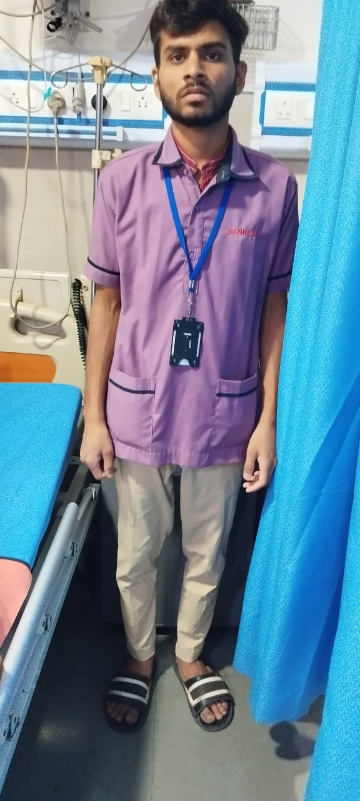**Background**:

Growing up in Shivrajpur, Pratham witnessed the struggles of his family as they relied on the income generated from his father's tailoring business. Despite learning the trade and assisting his father, Pratham recognized the limitations of their earnings in meeting the family's financial needs.

**Discovery of Opportunity**:

Pratham's journey took a significant turn when he learned about the GDA course through our mobilizer. Recognizing this as an opportunity to acquire new skills and secure better employment prospects, Pratham enrolled in the course alongside some friends.

**Training and Employmen**t:

Determined to improve his circumstances, Pratham diligently completed the training program and secured a position as a Patient Care Assistant at Sunshine Global Hospital in Vadodara. With a monthly salary of Rs. 13,494, Pratham gained not only financial stability but also confidence in his ability to support himself and his family.

**Dedication and Support**:

Pratham's commitment to his family's well-being was exemplified when his father fell ill and was hospitalized. Despite the challenges, Pratham continued working to manage the expenses of his father's treatment, demonstrating his unwavering dedication and responsibility.

**Gratitude and Reflection**:

Pratham attributes his success to his hard work, determination, and the opportunities provided by GMDC and Dr. Reddy's Foundation. He is grateful for the chance to achieve financial independence and support his family, and he acknowledges the transformative impact of the GDA course on his life.

**HQHCS Vadodara - GMDC - Samarthya 3rd Batch**

**Case Story:7**

**Title: Kaushalya's Journey: Overcoming Challenges with Determination**

**Introduction:**

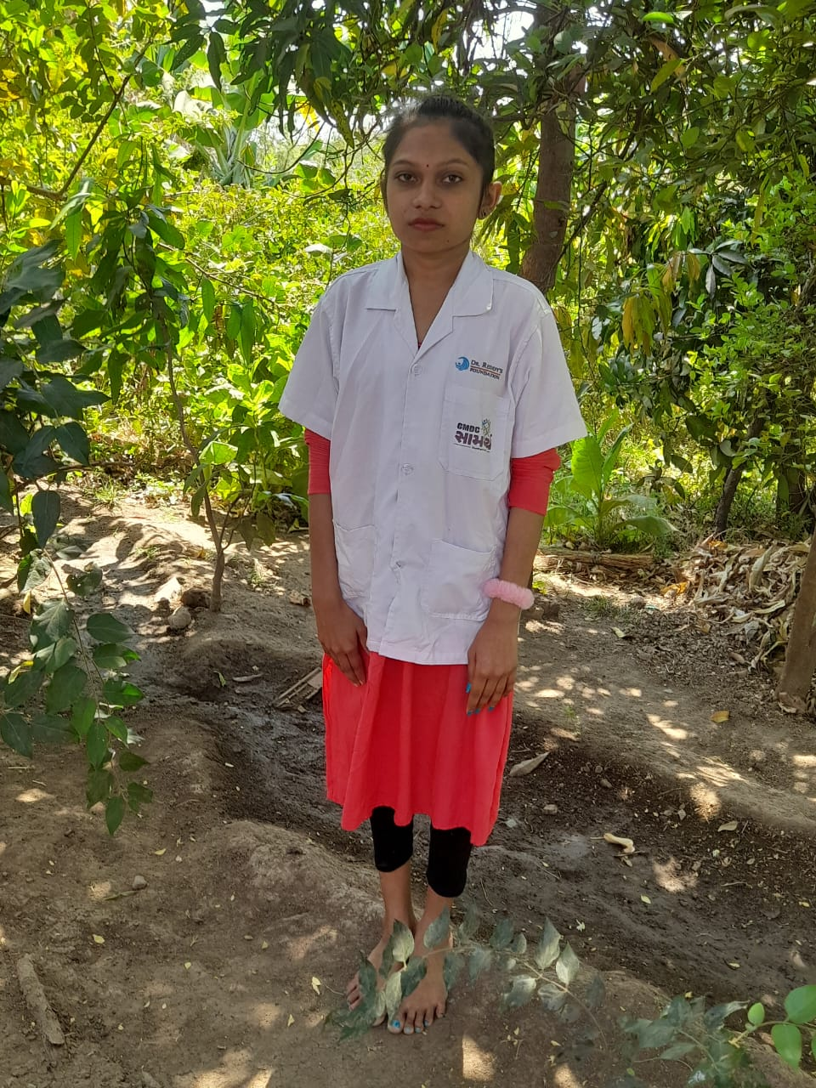Kaushalya's inspiring journey from Shiyali Village, Jhagadia Taluka, Bharuch District, is a testament to resilience, determination, and the transformative power of opportunity. Despite facing educational setbacks and physical challenges, Kaushalya's unwavering spirit and determination led her to pursue her dream of working in a hospital. Through the General Duty Assistant course offered by GMDC and Dr. Reddy's Foundation, Kaushalya found a path to empowerment and fulfillment, enabling her to support her family and contribute positively to society.

**Background:**

Born into a family where financial struggles were a constant reality, Kaushalya experienced the challenges of making ends meet from a young age. Faced with the responsibility of assisting her father in farming and witnessing his hardships, Kaushalya realized the importance of becoming a contributing member of her family.

**Discovery of Opportunity:**

Despite her educational limitations and physical condition, Kaushalya was determined to pursue her dream of working in a hospital. Upon learning about the General Duty Assistant course, Kaushalya saw it as a beacon of hope and decided to enroll, alongside a few friends, at the Vadodara center.

**Training and Employment**:

Throughout the course, Kaushalya's positivity, enthusiasm, and resilience shone brightly. Despite facing challenges with her walking, she persevered and completed her training. Her dedication paid off when she secured a position as a Patient Care Assistant at Sardar Vallabhbhai Patel Hospital in Ahmedabad, earning a monthly salary of 11,500 rupees for an 8-hour shift.

**Gratitude and Fulfillment**:

Kaushalya's joy and gratitude for her job are palpable, as she recognizes the life-changing opportunity provided by GMDC and Dr. Reddy's Foundation. Her employment not only brings her personal fulfillment but also serves as a source of support and stability for her family.

**Conclusion**:

Kaushalya's journey exemplifies the power of determination, resilience, and seizing opportunities in the face of adversity. Despite her educational and physical challenges, Kaushalya's unwavering spirit enabled her to overcome obstacles and achieve her dream of working in a hospital. Her story serves as an inspiration to all, reminding us that with perseverance and determination, anything is possible.

**HQHCS Vadodara - GMDC - Samarthya 3rd Batch**

**Case Story:8**

**Title: Parul's Journey: From Farm Work to Hospital Service**

**Introduction:**

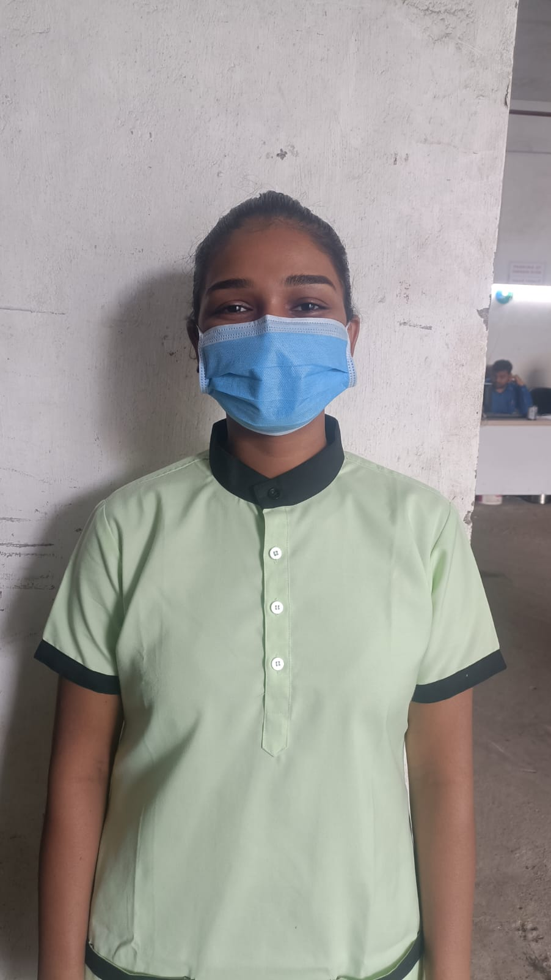Parul's journey from Bharuch district, Gujarat, is a testament to her resilience, determination, and the transformative power of education and opportunity. Despite facing financial constraints and dropping out of school, Parul's innate talent and desire for self-improvement propelled her towards a brighter future. Through the General Duty Assistant Course offered by Dr. Reddy's Foundation in Vadodara, Parul found a path to financial stability, personal growth, and self-reliance.

**Background:**

Following her schooling, Parul found herself in a challenging financial situation, prompting her to leave formal education and assist her family by working on a farm near her home. Despite her circumstances, Parul's strong work ethic and positive demeanor set her apart.

**Discovery of Opportunity**:

Parul's interest in nursing remained strong, despite her inability to pursue formal education in the field due to financial constraints. When she learned about the General Duty Assistant Course through a village meeting, she saw it as an opportunity to gain valuable skills and secure meaningful employment.

**Training and Employment**:

Despite initial hesitations about the distance from her home, Parul's determination led her to enroll in the program. The course proved to be a turning point for her, as it equipped her with the necessary skills to secure a position at Sterling Multispecialty Hospital in Vadodara, earning a monthly salary of 19,729 Rs as part of Shree Hari Associates.

**Financial Stability and Growth**:

Parul's employment not only provided her with financial stability but also instilled a sense of confidence and pride in her abilities. Her family rejoices in her newfound independence and achievements, recognizing her growth and success as a testament to her determination and perseverance.

**Conclusion**:

Parul's journey from farm work to hospital service underscores the transformative impact of education and opportunity in shaping lives and empowering individuals to overcome adversity. Her story serves as an inspiration to others, reminding us that with determination, resilience, and access to opportunities, one can overcome challenges and achieve their dreams.

**HQHCS Vadodara - GMDC - Samarthya 3rd Batch**

**Case Story:9**

**Title: Parul's Journey: From Farm Work to Hospital Service**

**Title: Tara's Journey: From Education Struggles to Empowerment**

**Introduction:**

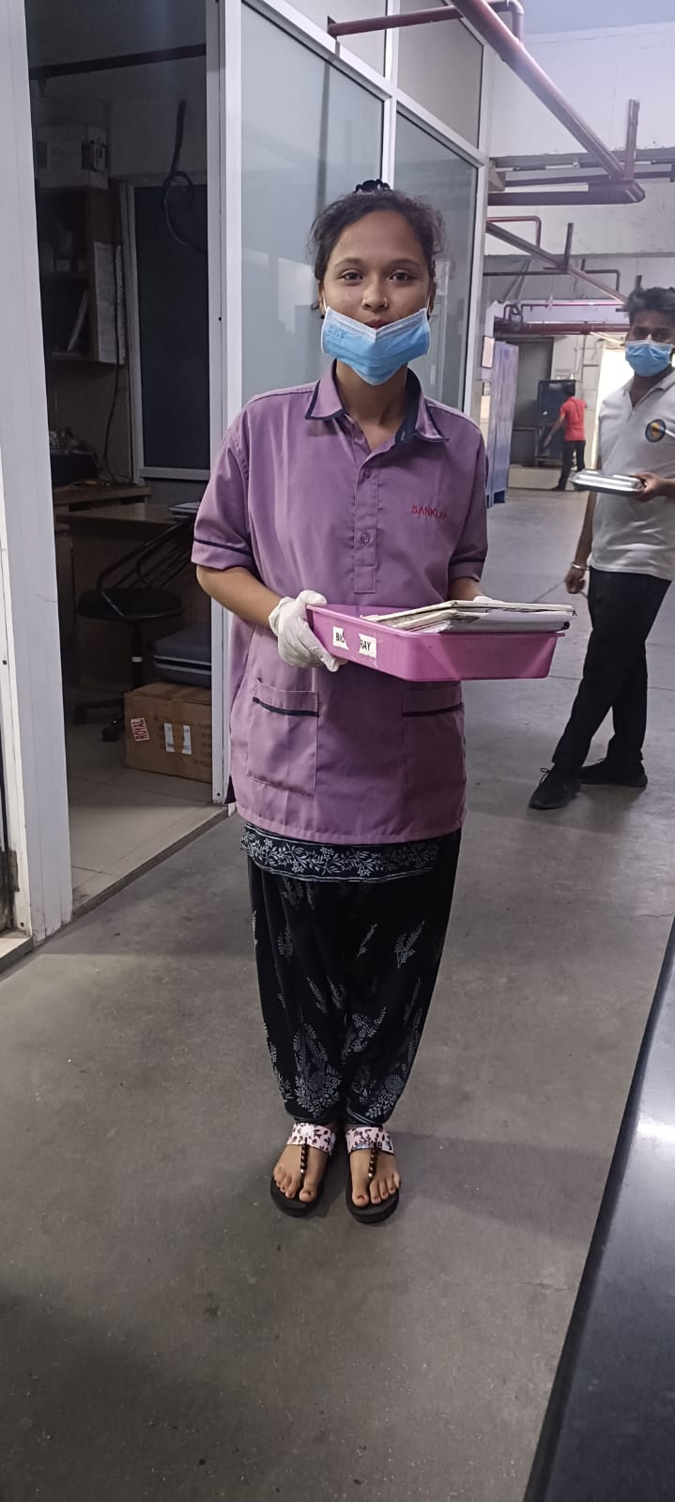Tara's story from Mogara, Chhotaudepur district of Gujarat, is a testament to resilience, determination, and the transformative power of education and opportunity. Despite facing financial constraints that hindered her pursuit of higher education, Tara's determination to support her family led her to enroll in a training program offered by Dr. Reddy's Foundation. Through her dedication and hard work, Tara secured a job at Sunshine Global Hospital in Vadodara, becoming a source of support and inspiration for her family.

**Background:**

Having completed her 12th grade education and enrolling in college for Bachelor of Arts, Tara's dreams of higher education were dashed by the financial burden it imposed on her family. Realizing the strain, it would place on her father's finances, Tara sought alternative paths to self-improvement and financial stability.

**Discovery of Opportunity**:

When Tara learned about the opportunities available through training programs offered by Dr. Reddy's Foundation, she saw it as a chance to acquire valuable skills and secure meaningful employment. Enrolling in the course, Tara embarked on a journey towards empowerment and self-reliance.

**Training and Employment**:

Completing the course equipped Tara with the necessary skills and confidence to enter the workforce. Successfully securing a position at Sunshine Global Hospital in Vadodara, Tara not only found financial stability but also a sense of purpose and fulfillment in her work. Praised by her supervisors for her sincerity and punctuality, Tara's dedication sets her apart as a valuable asset to the hospital.

**Financial Stability and Empowerment:**

Tara's employment not only provided her with financial stability but also boosted her confidence and sense of independence. Serving as a responsible and respected employee, Tara takes pride in her work and the positive impact she is making on her family and community.

Employer – Hospital Feedback

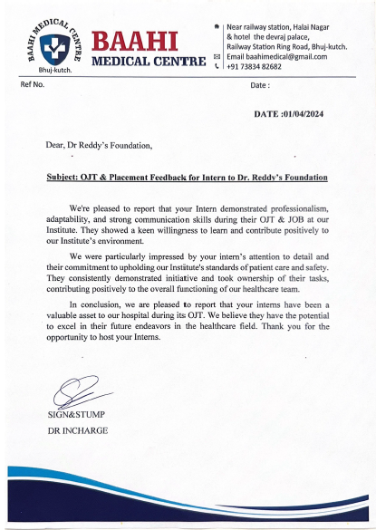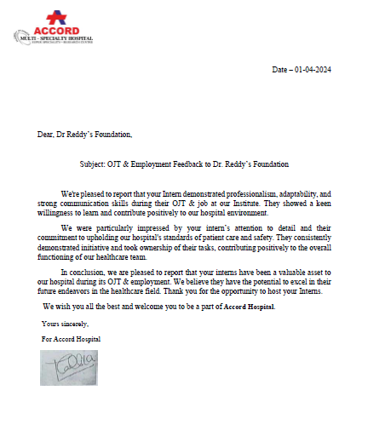

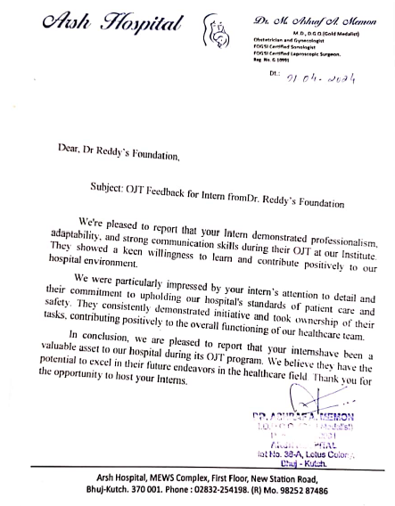

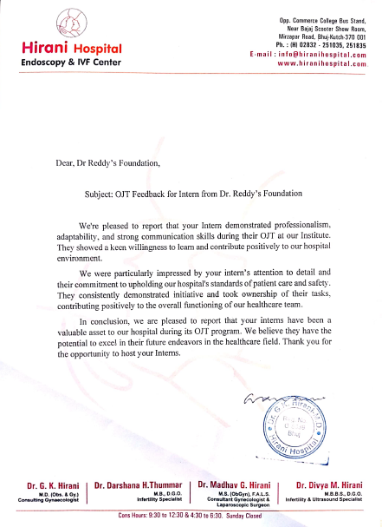

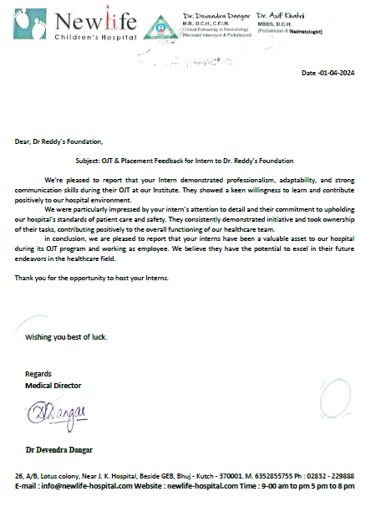 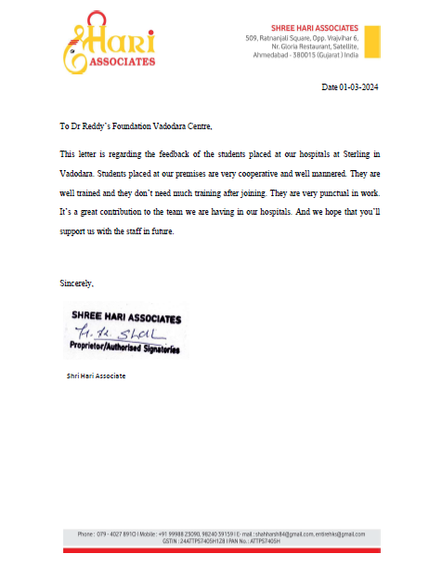

Community Feedback

