

**GMDC SAMARTHYA SKILL CENTER REPORT :- SURAT**

**Cours :- Warehouse Packer Presented By :- Quess Corp Limited**

**M Square, 5/6 3rd Floor, Opposite C.N.G Pump, NH No.48, Kadodara Char Rasta, At -Kadodara, Dist- Sura, Pincode - 394327, Gujarat**

**GMDC Samarthya Skill Training Centre:-** The GMDC Samarthya Skill Training Centre is a leading institution dedicated to empowering individuals with valuable skills and knowledge. Through their comprehensive training programs, they provide learners with the tools and confidence to take charge of their own personal and professional development. By fostering an environment of active learning and practical application, the centre aims to transform lives and create a more skilled and self-reliant workforce.



**About The Surat Centre :-** The GMDC Samarthya Skill Training Centre in Surat, Gujarat, is a leading vocational training institute that provides high-quality, industry-relevant education and skills development programs. Established by the Gujarat Mineral Development Corporation (GMDC), this state-of-the-art facility offers a diverse range of courses designed to empower individuals and meet the growing demands of the local and regional job market.

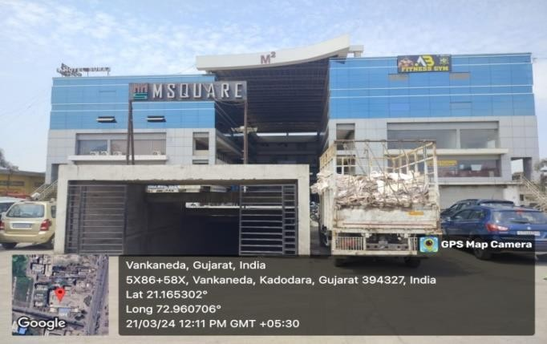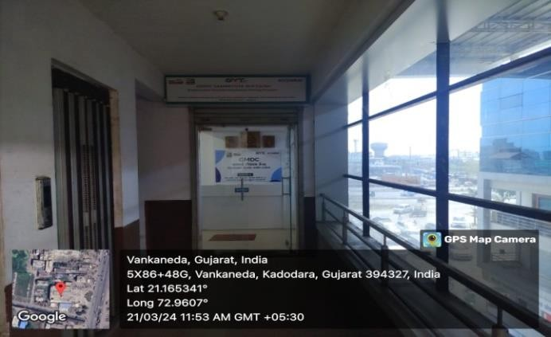

## Rationale – for the course and the respective selected areas started for the particular courses in Surat.

The rationale for establishing courses in selected areas at Surat is large area of Industries working in the district so we selected course in area survey and demands of jobs in warehouse.

* **Local Industry Demand:-** Surat have a significant presence of industries such as textiles, diamond cutting and polishing, Manufacturing, Textiles, (E-commerce ) Amazon, Flipkart, Delivery warehouses & Solar Company and various manufacturing sectors, which rely heavily on warehouse operations. A warehouse packer course would be selected to cater to the high demand for skilled packing personnel in these industries.
* **Skill Enhancement:-** There are be a recognition within the local Industries or business community that improving the skills of the workforce, particularly in logistics and warehousing, is crucial for the region's competitiveness. Starting a packer course would align with efforts to enhance the skill levels of workers in Surat.
* **Supporting Small and Medium Enterprises (SMEs):-** Surat have a significant presence of small and medium- sized enterprises (SMEs) involved in manufacturing and trade. Offering a warehouse packer course would support these SMEs by providing them with access to trained personnel for their packing operations, thereby improving their competitiveness.
* **Addressing Unemployment or Underemployment:-** Surat face challenges related to unemployment or underemployment, particularly among the youth or less skilled workers. Starting a packer course could help address this issue by providing individuals with the necessary skills to secure jobs in the warehouse and logistics sector.
* **Feedback from Industry Stakeholders:-** Input from local businesses, industry associations, and employers have indicated a shortage of skilled workers in warehouse packing roles in Surat. Starting a packer course could be a response to this feedback, aimed at bridging the skills gap and meeting the needs of the local labor market.

In summary, selecting and starting a warehouse packer course in Surat driven by a combination of factors related to local industry demand, economic development goals, skill enhancement objectives, support for SMEs, and government initiatives, all aimed at addressing specific challenges and opportunities in the region. Government initiatives, all aimed at addressing specific challenges and opportunities in the region.

## Approach – Mobilization & registration :-

Mobilization and registration at GMDC Surat center involve strategic approaches to reach potential candidates, inform them about the available courses, and facilitate their enrollment. Here's an overview of the approach:

* **Target Audience Identification**:- The first step is to identify the target audience for the courses offered at GMDC Surat. This may include unemployed youth, school dropouts, college graduates, or individuals looking to upskill or reskill in specific sectors.
* **Community Outreach**:- The center conducts extensive community outreach programs to create awareness about the courses. This may involve organizing workshops, seminars, or information sessions in collaboration with local organizations, schools, colleges, ITI and community leaders.
* **Digital Marketing**:- Leveraging digital platforms such as social media, websites, and online advertisements helps reach a wider audience. GMDC Surat utilizes targeted digital marketing campaigns to promote courses and engage with potential candidates.
* **Partnerships and Collaborations**:- Collaborating with local government bodies, NGOs, industry associations, and employers can help enhance mobilization efforts. These partnerships provide access to resources, networks, and referral pathways for candidate outreach.
* **Door-to-Door Campaigns**:- In areas with limited internet access or awareness, door-to-door campaigns are conducted to directly engage with potential candidates. Trained mobilization teams visit households, distribute flyers, and personally interact with individuals to explain the benefits of the courses.
* **Career Counselling**:- Offering career counselling services helps candidates make informed decisions about course selection based on their interests, skills, and career goals. GMDC Surat provides counselling sessions where trained professionals guide candidates through the enrolment process and address their queries.
* **Registration Assistance**:- Simplifying the registration process encourages more candidates to enroll. The center provides easy-to-understand registration forms, online registration portals, and assistance desks where candidates can seek help with completing the registration formalities.
* **Follow-Up and Feedback**:- Continuous follow-up with registered candidates ensures their commitment to the course. GMDC Surat maintains regular communication through phone calls, SMS, emails, or in-person visits to provide updates, reminders, and support throughout the enrolment process.

By adopting a multi-faceted approach to mobilization and registration, GMDC Surat maximizes outreach, engagement, and enrolment, thereby facilitating skill development and empowerment within the community.

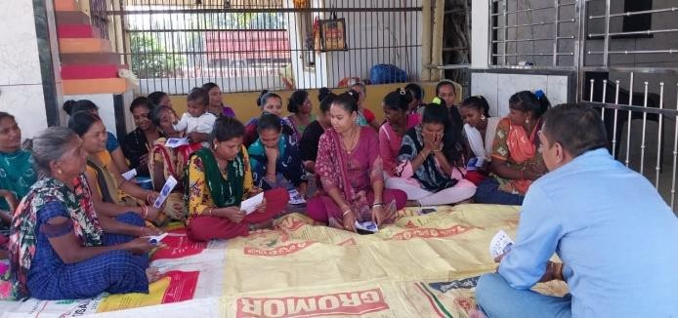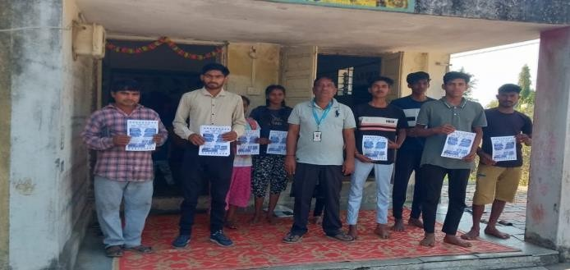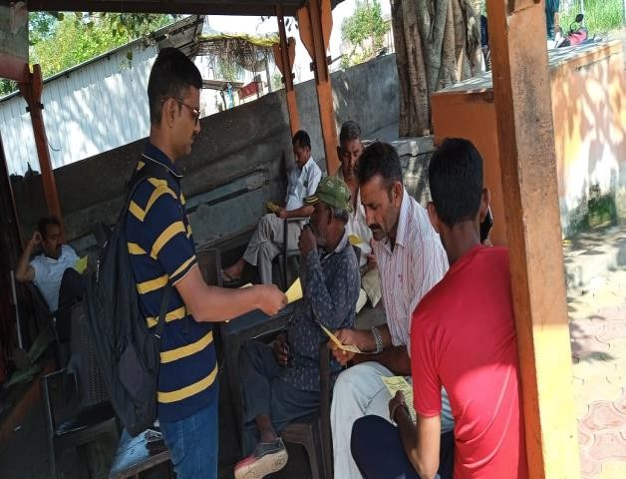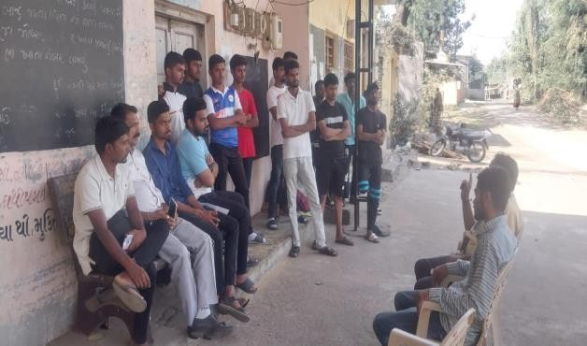

## Course conduct, language, workbooks and all efforts put up for the course conduct-Hostels, Classroom, Faculties/trainers

Course Conduct, Language, Workbooks, and Efforts:

* **Course Conduct**:- The courses at GMDC Surat center are conducted in a structured manner, adhering to predefined schedules and syllabi. Regular classes, practical sessions, workshops, and assessments are organized to ensure comprehensive learning experiences for participants.
* **Language**:- The medium of instruction depends on the course and the target audience. Courses may be conducted in regional languages such as Gujarati or Hindi, or in English for technical or professional programs. Bilingual materials and instructions are provided to accommodate diverse linguistic preferences.
* **Workbooks**:- Workbooks and study materials are developed specifically for each course, incorporating relevant theories, concepts, exercises, and case studies. These workbooks serve as comprehensive guides for participants, facilitating self-study and revision outside of class hours.
* **Efforts**:- GMDC Surat center invests significant efforts in course preparation, delivery, and evaluation. Qualified instructors and subject matter experts are engaged to design curriculum, develop content, and deliver sessions effectively. Continuous feedback mechanisms are implemented to assess the quality of teaching and learning experiences, enabling ongoing improvement.

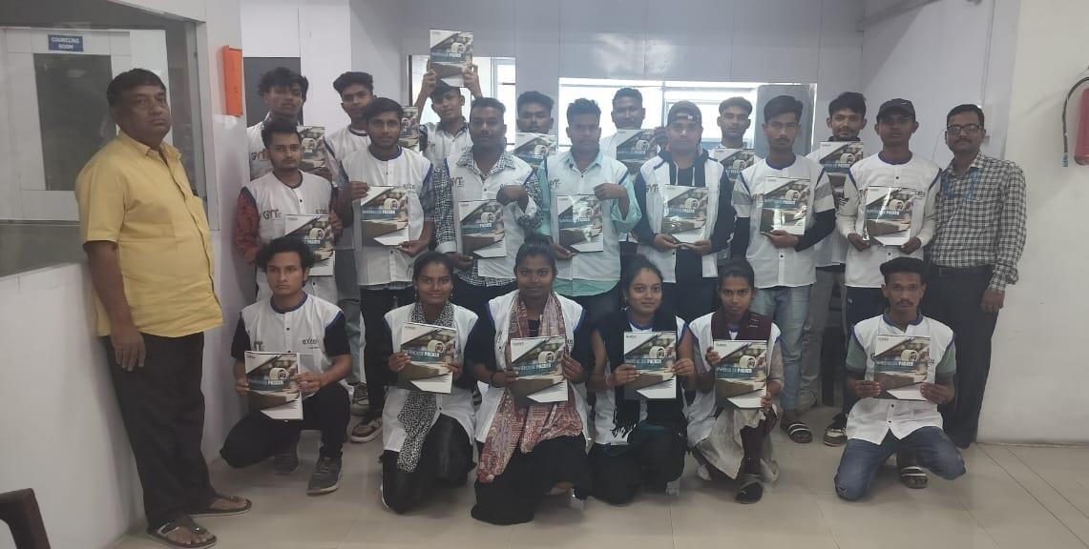

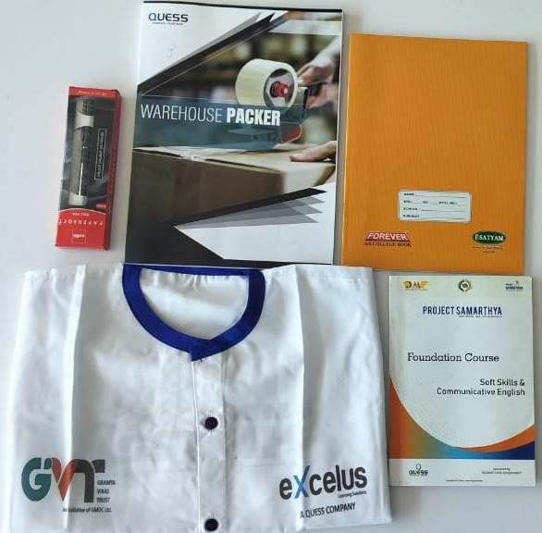

**Hostels, Classrooms, Faculties/Trainers**:

* **Hostels**: The center may provide hostel facilities for outstation participants, offering accommodation, meals, and basic amenities. These hostels ensure a conducive living environment for students, allowing them to focus on their studies without worrying about lodging arrangements.
* **Classrooms**: Modern and well-equipped classrooms are available at GMDC Surat center, furnished with comfortable seating, audio-visual aids, and interactive whiteboards. These classrooms provide a conducive learning environment, fostering engagement, interaction, and knowledge exchange among participants.
* **Faculties/Trainers**: Experienced and qualified faculties/trainers are appointed to deliver courses at GMDC Suart center. These trainers possess expertise in their respective domains and employ innovative teaching methodologies to engage participants effectively. Regular training sessions and workshops are conducted to enhance the skills and competencies of faculties/trainers, ensuring high-quality education delivery.

Overall, GMDC Surat center prioritizes the provision of quality education and training facilities, aiming to empower individuals with the knowledge and skills needed to succeed in their chosen fields.

**-:Class Room Training :- -:Domain Lab Training :-**

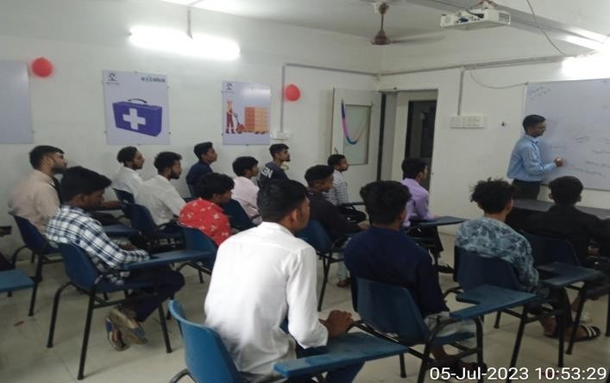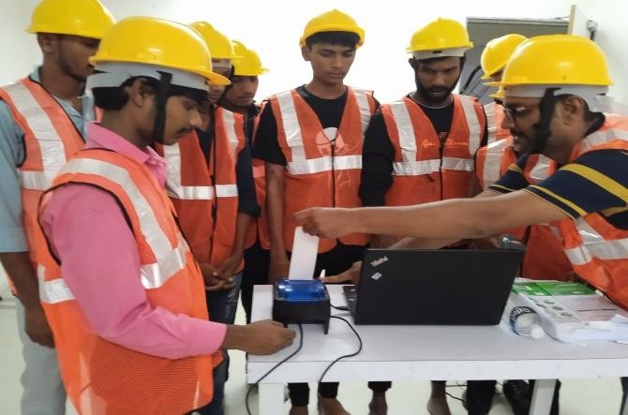

**IT Lab Trraining :-**

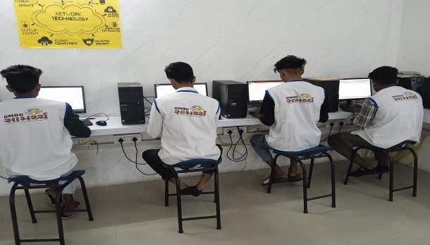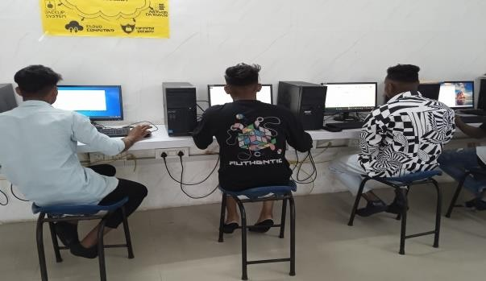

**Hostel Facility :-**

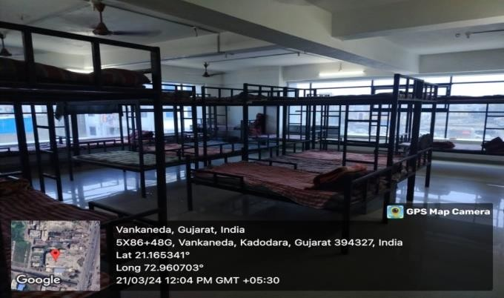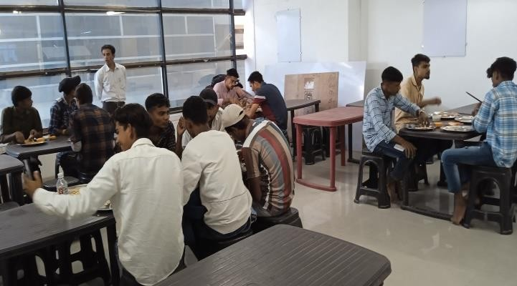

**OJT – Industries were placed for OJT, candidates, companies and Agency feedback**

On-the-Job Training (OJT) at GMDC Surat Center involves placing candidates in various industries to gain practical work experience.

* **Industries for OJT**: Candidates are placed in a diverse range of industries based on their course specialization. These industries may include manufacturing, hospitality, healthcare, retail, IT, construction, and agriculture, among others.
* **Candidates**: Participants enrolled in training programs at GMDC Surat Center are selected for OJT based on their academic qualifications, skills, and interests. They undergo rigorous training before being placed in industries for hands-on experience.
* **Companies**: GMDC Surat Center collaborates with a network of reputed companies and organizations to facilitate OJT opportunities for candidates. These companies provide a supportive environment for candidates to apply their theoretical knowledge in real-world settings.
* **Agency Feedback**: Feedback from both candidates and partner companies/agencies is crucial for evaluating the effectiveness of OJT programs. Agencies monitor candidates' progress, provide mentorship, and assess their performance during the training period. Likewise, companies provide feedback on candidates' skills, attitude, and readiness for employment.

Overall, OJT at GMDC Surat Center serves as a bridge between classroom learning and industry requirements, allowing candidates to acquire practical skills, build confidence, and enhance their employability in their chosen field.

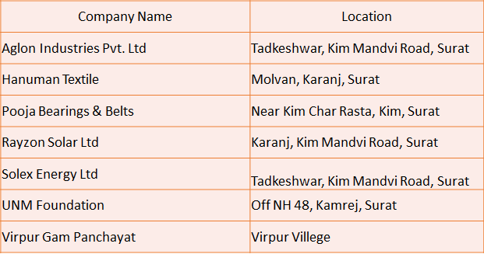

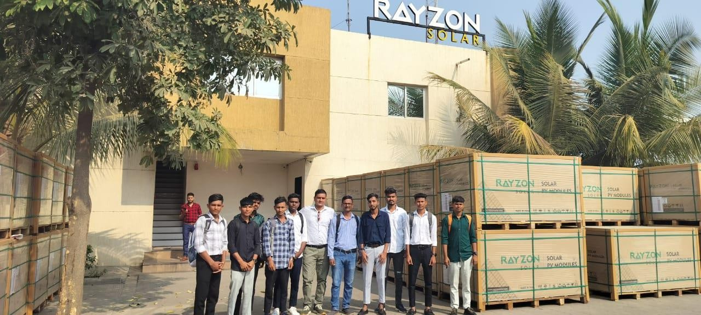

Evaluation and examination at GMDC Surat Center are conducted to assess the performance and progress of batches enrolled in various training programs. Here's a brief overview

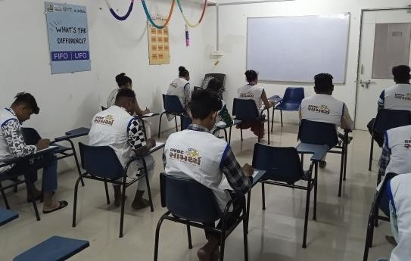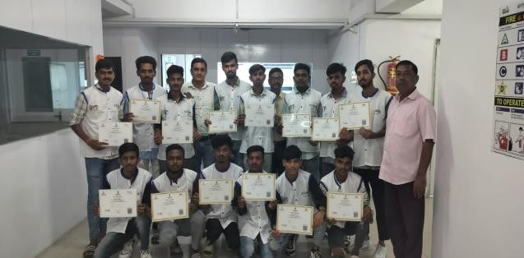

* **Assessment Methods**: Multiple assessment methods are employed to evaluate the knowledge, skills, and competency of students. These may include written tests, practical demonstrations, presentations, projects, and viva voce examinations.
* **Evaluation Criteria**: The evaluation criteria are aligned with the learning objectives and course curriculum. Students are assessed based on their understanding of theoretical concepts, application of practical skills, critical thinking abilities, and overall performance in assignments and examinations.
* **Regular Feedback**: Continuous feedback is provided to students throughout the training period to identify areas for improvement and track their progress. Trainers and instructors offer constructive feedback on assignments, projects, and class participation, fostering a culture of continuous learning and development.
* **Examination Schedule**: Examinations are scheduled periodically to measure students' understanding and retention of course material. The examination schedule is communicated in advance, allowing students to prepare adequately and perform to the best of their abilities.
* **Grading System**: A grading system is used to evaluate students' performance, assigning grades based on their scores in examinations, assignments, and overall participation. The grading system provides a standardized method for assessing students' achievements and communicating their progress.
* **Performance Analysis**: After the examinations, performance analysis is conducted to review the results and identify trends. This analysis helps instructors and administrators understand the strengths and weaknesses of the batch, enabling them to tailor interventions and support as needed.

Overall, the evaluation and examination process at GMDC Surat Center aims to ensure fair and transparent assessment of students' performance, providing them with opportunities for growth, development, and success in their chosen fields.

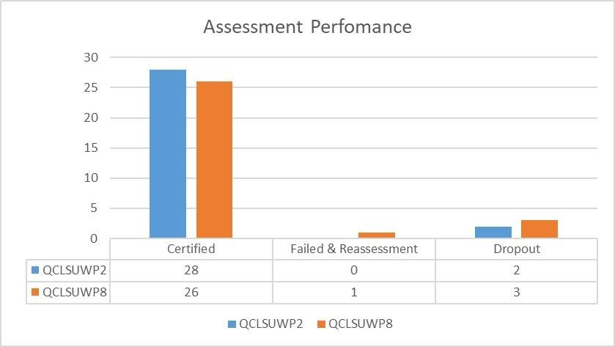

## Agency

Placements at GMDC Surat Center involve facilitating employment opportunities for candidates in various geographical areas and industries/service sectors.

* **Geographical Areas**: Candidates may be placed in different geographical areas based on job availability and their preferences. These areas may include local regions within Gujarat, as well as other states across India, depending on the demand for skilled professionals in different sectors.
* **Industries/Service Sectors**: Candidates are placed in a wide range of industries and service sectors based on their qualifications, skills, and career aspirations. These sectors may include manufacturing, Solar, E- Commerce, hospitality, healthcare, IT, retail, construction, banking, finance, agriculture, and more.
* **Experience Sharing**: Both candidates and agencies share their experiences regarding placements at GMDC Surat Center. Candidates provide feedback on their placement journey, including the application process, interviews, and job roles. Agencies also share their insights on candidate performance, employability, and industry demand.
* **Agency Collaboration**: GMDC Surat Center collaborates with placement agencies, recruitment firms, industry associations, and employers to facilitate placements. These agencies play a crucial role in connecting candidates with job opportunities, conducting interviews, and negotiating job offers on their behalf.
* **Support Services**: The center provides support services to candidates during the placement process, including resume writing assistance, interview preparation workshops, and career counselling sessions. This support helps candidates navigate the job market more effectively and increase their chances of securing employment.

Overall, placements at GMDC Surat Center aim to match candidates with suitable job opportunities in diverse industries and geographical areas, ultimately enhancing their employability and facilitating their transition into the workforce.

1st & 2nd Batch Total Job Roall wise Placed Candidates

Trainee

Operatior/Helper - Production

Operatior/Helper Marketing Executive Hyac Technician Helper Packaging

Computer Operator

0

2

4

6

8

10

12

14

16

1st & 2nd Batch Total Placed Candidate Month wise

14

12

10

8

6

4

2

0

Aug-23 Sep-23 Oct-23 Nov-23 Dec-23

|  |  |  |  |  |
| --- | --- | --- | --- | --- |
| **Batch ID** | **Start Date** | **End Date** | **Candidate Name** | **CN Number** |
| QCLSUWP2 | 27-May-23 | 26-Jul-23 | Alpesh Shantubhai Patel | CN20230041 |

# Introduction:-

Alpesh Shantubhai Patel, from Tadkeshwar Village,Taluka Mandvi, District-Surat Batch-01 he completed higher secondary education in Falahi higher Secndary school, Tadkeshwar he is Belong from farmer’s family his father and mother both are working on farm. He did a Warehouse Packer Course at Surat though the GMDC

Samarthya program. He interviewed at UNM Foundation and got selected by UNM Foundation, Kamrej (Torrent Power Ltd)

# Enrollment in Course:-

Alpesh come at community meeting in tadkeshwar village and interested in our course so enrolling in training programs offered by Excelus Learning Solutions Pvt Ltd at Surat. He chooses courses based on their interests, career goals, and skill development needs. The enrolment process involves filling out application forms, attending orientation sessions, and undergoing skill assessments to determine the most suitable course for candidate.

# Training and development:-

Training in Project “SAMARTHYA” Program over the course of 3 month under training helped his to gain knowledge about Warehouse Packer domain and other Market Research & Development activity a skilled professional with improved communication skills and growth mindset create a work environment that both challenges and supports people.

# Performance and Impact:-

Alpesh performance was good in written English test under the training program he participated in internal assessment and final assessment he has passed all exams. In final exam he got 349 marks out of 500 marks.

# Carrier Impact after Job:-

He interviewed at UNM Foundation service UNM Foundation (Torrent Power Ltd) Ta - Kamrej and he selected of HYAC Technician post and salary given by 26638/- per month. He is supporting family to archive financial stability.

# Family satisfaction and Community response:-

His family is proud of him for his job in the archive. The community response to GMDC Skill centre Surat initiatives has been overwhelmingly positive, reflecting its significant impact on the socio-economic fabric of the region. Local residents view the centre as a beacon of hope and opportunity, providing valuable skill development and training programs tailored to meet the needs of the community. GMDC Skill Centre Surat continues to be a catalyst for positive change, driving economic empowerment, social inclusion, and sustainable development in the region.

|  |  |  |  |  |
| --- | --- | --- | --- | --- |
| **Batch ID** | **Start Date** | **End Date** | **Candidate Name** | **CN Number** |
| QCLSUWP2 | 27-May-23 | 26-Jul-23 | Saiyad Mahmadjed  Mahmad Hanif | CN20230077 |

# Introduction:-

Saiyad Mahmadjed Mahmad Hanif , from Tadkeshwar Village,Taluka Mandvi, District-Surat Batch-01 he completed secondary education in Tadkeshwar Vibhag High School, Tadkeshwar he is Belong from daily wages worker his father and mother both are working has daily wages worker. He did a Warehouse Packer

Course at Surat though the GMDC Samarthya Program. He interviewed at Aglon Textile Industries Pvt Ltd and got selected by Company Hr.

# Enrollment in Course:-

Saiyad Mahmadjed Mahmad Hanif, come at community meeting in tadkeshwar village and interested in our course so enrolling in training programs offered by Excelus Learning Solutions Pvt Ltd at Surat. He chooses courses based on their interests, career goals, and skill development needs. The enrolment process involves filling out application forms, attending orientation sessions, and undergoing skill assessments to determine the most suitable course for candidate.

# Training and development:-

Training in Project “SAMARTHYA” Program over the course of 3 month under training helped his to gain knowledge about Warehouse Packer domain and other Market Research & Development activity a skilled professional with improved communication skills and growth mindset create a work environment that both challenges and supports people.

# Performance and Impact:-

Saiyad Mahmadjed Mahmad Hanif, performance was good in written English test under the training program he participated in internal assessment and final assessment he has passed all exams. In final exam he got 350 marks out of 500 marks.

# Carrier Impact after Job:-

He interviewed at Aglon Textile Industries Pvt Ltd At Post Tadkeshwaar Ta - Mandvi and he selected of Operator post and salary given by 13000/- per month. He is supporting family to archive financial stability.

# Family satisfaction and Community response:-

His family is proud of him for his job in the archive. The community response to GMDC Skill centre Surat initiatives has been overwhelmingly positive, reflecting its significant impact on the socio-economic fabric of the region. Local residents view the centre as a beacon of hope and opportunity, providing valuable skill development and training programs tailored to meet the needs of the community. GMDC Skill Centre Surat continues to be a catalyst for positive change, driving economic empowerment, social inclusion, and sustainable development in the region.

|  |  |  |  |  |
| --- | --- | --- | --- | --- |
| **Batch ID** | **Start Date** | **End Date** | **Candidate Name** | **CN Number** |
| QCLSUWP2 | 27-May-23 | 26-Jul-23 | Chirag Navinbhai Patel | CN20230140 |

# Introduction:-

Chirag Navinbhai Patel, from Roswad Village, Taluka Mandvi, District-Surat Batch-01 he completed higher secondary education in Tadkeshwar Vibhag High School, Tadkeshwar. His father and mother both are working in Small Shop in village. He did a Warehouse Packer Course at Surat though the GMDC Samarthya

program. He interviewed at Solex Energy Pvt. Ltd and got selected by Company contractor.

# Enrollment in Course:-

Chirag Navinbhai Patel, come at community meeting in Roswad village and interested in our course so enrolling in training programs offered by Excelus Learning Solutions Pvt Ltd at Surat. He chooses courses based on their interests, career goals, and skill development needs. The enrolment process involves filling out application forms, attending orientation sessions, and undergoing skill assessments to determine the most suitable course for candidate.

# Training and development:-

Training in Project “SAMARTHYA” Program over the course of 3 month under training helped his to gain knowledge about Warehouse Packer domain and other Market Research & Development activity a skilled professional with improved communication skills and growth mindset create a work environment that both challenges and supports people.

# Performance and Impact:-

Chirag Navinbhai Patel, performance was good in written English test under the training program he participated in internal assessment and final assessment he has passed all exams. In final exam he got 343 marks out of 500 marks.

# Carrier Impact after Job:-

He interviewed at Solex Energy Pvt. Ltd at Tadkeshwar and he selected of Operator post and salary given by 13144/- per month. He is supporting family to archive financial stability.

# Family satisfaction and Community response:-

His family is proud of him for his job in the archive. The community response to GMDC Skill centre Surat initiatives has been overwhelmingly positive, reflecting its significant impact on the socio-economic fabric of the region. Local residents view the centre as a beacon of hope and opportunity, providing valuable skill development and training programs tailored to meet the needs of the community. GMDC Skill Centre Surat continues to be a catalyst for positive change, driving economic empowerment, social inclusion, and sustainable development in the region.

|  |  |  |  |  |
| --- | --- | --- | --- | --- |
| **Batch ID** | **Start Date** | **End Date** | **Candidate Name** | **CN Number** |
| QCLSUWP8 | 26-Jun-23 | 26-Aug-23 | Rinkesh Natvarbhai Ahir | CN20230269 |

# Introduction:-

Rinkesh Natvarbhai Ahir, from Tadkeshwar Village,Taluka Mandvi, District-Surat Batch-02 he completed higher secondary education in Falahi higher Secndary school, Tadkeshwar he is Belong from farmer’s family his father and mother both are working on farm. He did a Warehouse Packer Course at Surat though the GMDC Samarthya program. He interviewed at Pooja Bearings and Belts Pvt Ltd and got selected by Company.

# Enrollment in Course:-

Rinkesh Natvarbhai Ahir, come at community meeting in tadkeshwar village and interested in our course so enrolling in training programs offered by Excelus Learning Solutions Pvt Ltd at Surat. He chooses courses based on their interests, career goals, and skill development needs. The enrolment process involves filling out application forms, attending orientation sessions, and undergoing skill assessments to determine the most suitable course for candidate.

# Training and development:-

Training in Project “SAMARTHYA” Program over the course of 3 month under training helped his to gain knowledge about Warehouse Packer domain and other Market Research & Development activity a skilled professional with improved communication skills and growth mindset create a work environment that both challenges and supports people.

# Performance and Impact:-

Rinkesh Natvarbhai Ahir, performance was good in written English test under the training program he participated in internal assessment and final assessment he has passed all exams. In final exam he got 362 marks out of 500 marks.

# Carrier Impact after Job:-

He interviewed at Pooja Bearings and Belts Pvt Ltd at kim and he selected of Marketing Executive post and salary given by 15000/- per month. He is supporting family to archive financial stability.

# Family satisfaction and Community response:-

His family is proud of him for his job in the archive. The community response to GMDC Skill centre Surat initiatives has been overwhelmingly positive, reflecting its significant impact on the socio-economic fabric of the region. Local residents view the centre as a beacon of hope and opportunity, providing valuable skill development and training programs tailored to meet the needs of the community. GMDC Skill Centre Surat continues to be a catalyst for positive change, driving economic empowerment, social inclusion, and sustainable development in the region.

|  |  |  |  |  |
| --- | --- | --- | --- | --- |
| **Batch ID** | **Start Date** | **End Date** | **Candidate Name** | **CN Number** |
| QCLSUWP8 | 26-Jun-23 | 26-Aug-23 | Nikunj Takorbhai Parmar | CN20230338 |

# C:\Users\Quess\Downloads\WhatsApp Image 2024-04-04 at 11.03.07 AM.jpegIntroduction:-

Nikunj Takorbhai Parmar, from Tadkeshwar Village, Taluka Mandvi, District-Surat Batch-02 he completed secondary education in Tadkeshwar Vibhag High School, Tadkeshwar he is Belong from daily wages worker his father was past awey and mother is working has daily wages worker. He did a Warehouse Packer Course at Surat though the GMDC Samarthya Program. He interviewed at Rayon Solar Pvt

Ltd and got selected by Company Hr.

# Enrollment in Course:-

Nikunj Takorbhai Parmar, come at community meeting in tadkeshwar village and interested in our course so enrolling in training programs offered by Excelus Learning Solutions Pvt Ltd at Surat. He chooses courses based on their interests, career goals, and skill development needs. The enrolment process involves filling out application forms, attending orientation sessions, and undergoing skill assessments to determine the most suitable course for candidate.

# Training and development:-

Training in Project “SAMARTHYA” Program over the course of 3 month under training helped his to gain knowledge about Warehouse Packer domain and other Market Research & Development activity a skilled professional with improved communication skills and growth mindset create a work environment that both challenges and supports people.

# Performance and Impact:-

Nikunj Takorbhai Parmar, performance was good in written English test under the training program he participated in internal assessment and final assessment he has passed all exams. In final exam he got 397 marks out of 500 marks.

# Carrier Impact after Job:-

He interviewed at Rayon Solar Pvt Ltd At Post Tadkeshwaar Ta - Mandvi and he selected of Operator post and salary given by 17200/- per month. He is supporting family to archive financial stability.

# Family satisfaction and Community response:-

His family is proud of him for his job in the archive. The community response to GMDC Skill centre Surat initiatives has been overwhelmingly positive, reflecting its significant impact on the socio-economic fabric of the region. Local residents view the centre as a beacon of hope and opportunity, providing valuable skill development and training programs tailored to meet the needs of the community. GMDC Skill Centre Surat continues to be a catalyst for positive change, driving economic empowerment, social inclusion, and sustainable development in the region.

|  |  |  |  |  |
| --- | --- | --- | --- | --- |
| **Batch ID** | **Start Date** | **End Date** | **Candidate Name** | **CN Number** |
| QCLSUWP8 | 26-Jun-23 | 26-Aug-23 | Viralkumar Ishwarbhai Rathod | CN20230195 |

# C:\Users\Quess\Downloads\WhatsApp Image 2024-04-04 at 11.03.15 AM.jpegIntroduction:-

Viralkumar Ishwarbhai Rathod, from Bodhan Village, Taluka Mandvi, District-Surat Batch-02 he completed Higher Secondary Education in Bodhan High School, Bodhan he is Belong from daily wages worker his father and mother both are working has daily wages worker. He did a Warehouse Packer Course at Surat though the GMDC

Samarthya Program. He interviewed at Pooja Bearings and Belts Pvt Ltd and got selected by Company.

# Enrollment in Course:-

Viralkumar Ishwarbhai Rathod, come at community meeting in tadkeshwar village and interested in our course so enrolling in training programs offered by Excelus Learning Solutions Pvt Ltd at Surat. He chooses courses based on their interests, career goals, and skill development needs. The enrolment process involves filling out application forms, attending orientation sessions, and undergoing skill assessments to determine the most suitable course for candidate.

# Training and development:-

Training in Project “SAMARTHYA” Program over the course of 3 month under training helped his to gain knowledge about Warehouse Packer domain and other Market Research & Development activity a skilled professional with improved communication skills and growth mindset create a work environment that both challenges and supports people.

# Performance and Impact:-

Viralkumar Ishwarbhai Rathod,performance was good in written English test under the training program he participated in internal assessment and final assessment he has passed all exams. In final exam he got 272 marks out of 500 marks.

# Carrier Impact after Job:-

He interviewed at Pooja Bearings and Belts Pvt Ltd at kim and he selected of Marketing Executive post and salary given by 15000/- per month. He is supporting family to archive financial stability.

# Family satisfaction and Community response:-

His family is proud of him for his job in the archive. The community response to GMDC Skill centre Surat initiatives has been overwhelmingly positive, reflecting its significant impact on the socio-economic fabric of the region. Local residents view the centre as a beacon of hope and opportunity, providing valuable skill development and training programs tailored to meet the needs of the community. GMDC Skill Centre Surat continues to be a catalyst for positive change, driving economic empowerment, social inclusion, and sustainable development in the region.